

Scan QR code to download
digital version of this leaflet

Delirium

Information for patients, relatives and carers


This leaflet aims to help you to understand delirium better. It describes the main symptoms, how we treat them and things that can help, especially if the person with delirium is distressed. It also gives you practical strategies to support a person with delirium. If you have more questions at any time, please do not hesitate to contact a member of staff.

Confirming your identity
Before you have a treatment or procedure, our staff will ask you your name and date of birth and check your ID band. If you do not have an ID band we will also ask you to confirm your address. If we do not ask these questions, then please ask us to check. Ensuring your safety is our primary concern.

www.kch.nhs.uk
What is delirium?
Delirium is a state of confusion that can happen if you become medically unwell. It can also occur after surgery.
Symptoms can develop quickly, over hours or days. Delirium can fluctuate and symptoms are often worse at night.
Delirium is usually a temporary condition. The earlier it is identified and treated, the better the outcome for that person. However, for some people, the delirium can take months to resolve or they may not get back to their previous level of cognition and daily living ability.
Who is at risk of delirium?
Anyone can develop delirium, but the following factors increase risk:
- being over 65
- dementia, cognitive impairment or memory problems
- surgery – it is more common following brain surgery and cardiac (heart) bypass surgery
- hearing and/or sight loss
- a fractured hip
- a serious illness – particularly if this needs treatment in the Intensive Care Unit
- frailty or multiple health problems
- being on multiple medicines
- a stroke, head injury or liver disease
- previous episodes of delirium
Delirium is also common in people as they come towards the end of their life.
How can I tell if it’s delirium?
People are affected by delirium in different ways, but the person may:

- become restless
- be quieter or more sleepy than normal – this can also mean the person does not eat or drink enough or take their medicine
- be less able to perform their daily tasks, such as washing and dressing themselves
- be less aware of what is going on around them or where they are
- hear or see things that aren’t there (hallucinations)
- become suspicious of people’s intentions
- worry that people are trying to harm them
- be unable to follow a conversation or speak clearly
- resist care
- have vivid dreams, which are often frightening and may carry on when they wake up
- be more confused, especially in the evenings and at night
- feel an urge to wander around
- not recognise even close family
Delirium can be mistaken for a sudden worsening of dementia. It is important to recognise delirium and treat it as early as possible. If you notice symptoms of delirium, please inform the doctor or nurse looking after the person. They may not have been aware that anything was wrong, and friends and family may be the first to notice subtle changes. You may wish to show them this leaflet to help explain your concerns.
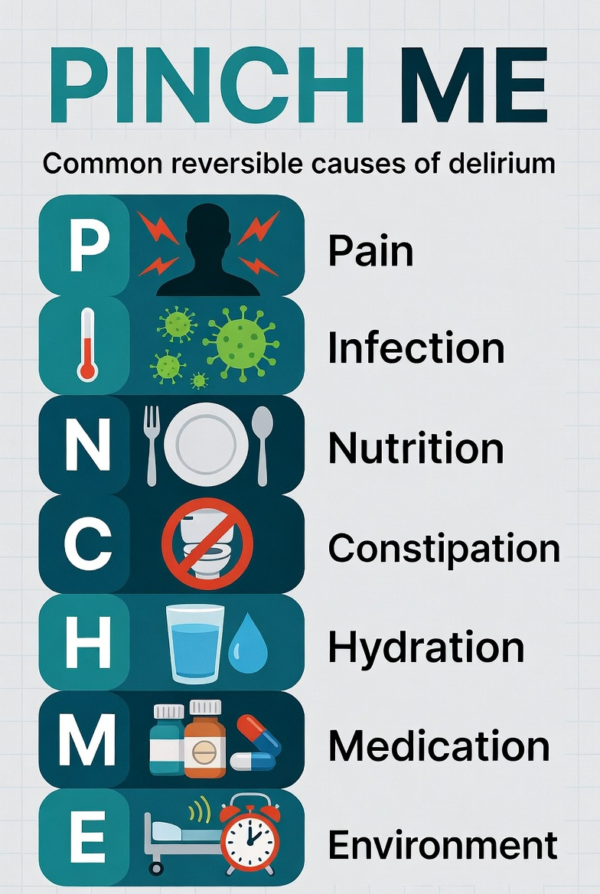
What causes delirium?
Common causes of delirium include:
- untreated pain
- infection
- poor nutrition
- dehydration
- constipation or being unable to pee
- medicines (for example, codeine, morphine or steroids)
- suddenly stopping taking medicine or alcohol
- recent surgery
- being in new place (especially the very busy hospital environment)
PINCH ME is a helpful way to remember the common causes of delirium.
Often delirium has more than one cause.
Unfortunately, sometimes the cause is not always found.


How can I prevent delirium?
It is not always possible to prevent delirium. However, if you're at risk of delirium, there are some things that you can do to reduce the risk yourself.
- Eat and drink regularly. This will help avoid dehydration and constipation.
- If you take lots of different medicines, ask your doctor or nurse to review them.
- Inform your doctor or nurse of any new medicines that have been prescribed for you (or bought over the counter).
- If you are in pain, take pain relief medicine.
- Get out of bed early and keep moving.
- Use glasses and hearing aids if needed.
- Good sleep helps to protect against delirium. Use eye masks and ear plugs in hospital and let staff know about your usual night-time routine (such as a hot uncaffeinated drink before bedtime).
- If you smoke, talk to a doctor or nurse as nicotine withdrawal can contribute to delirium.
- If you drink several alcoholic drinks per week, talk to a doctor or nurse as alcohol withdrawal can cause delirium.
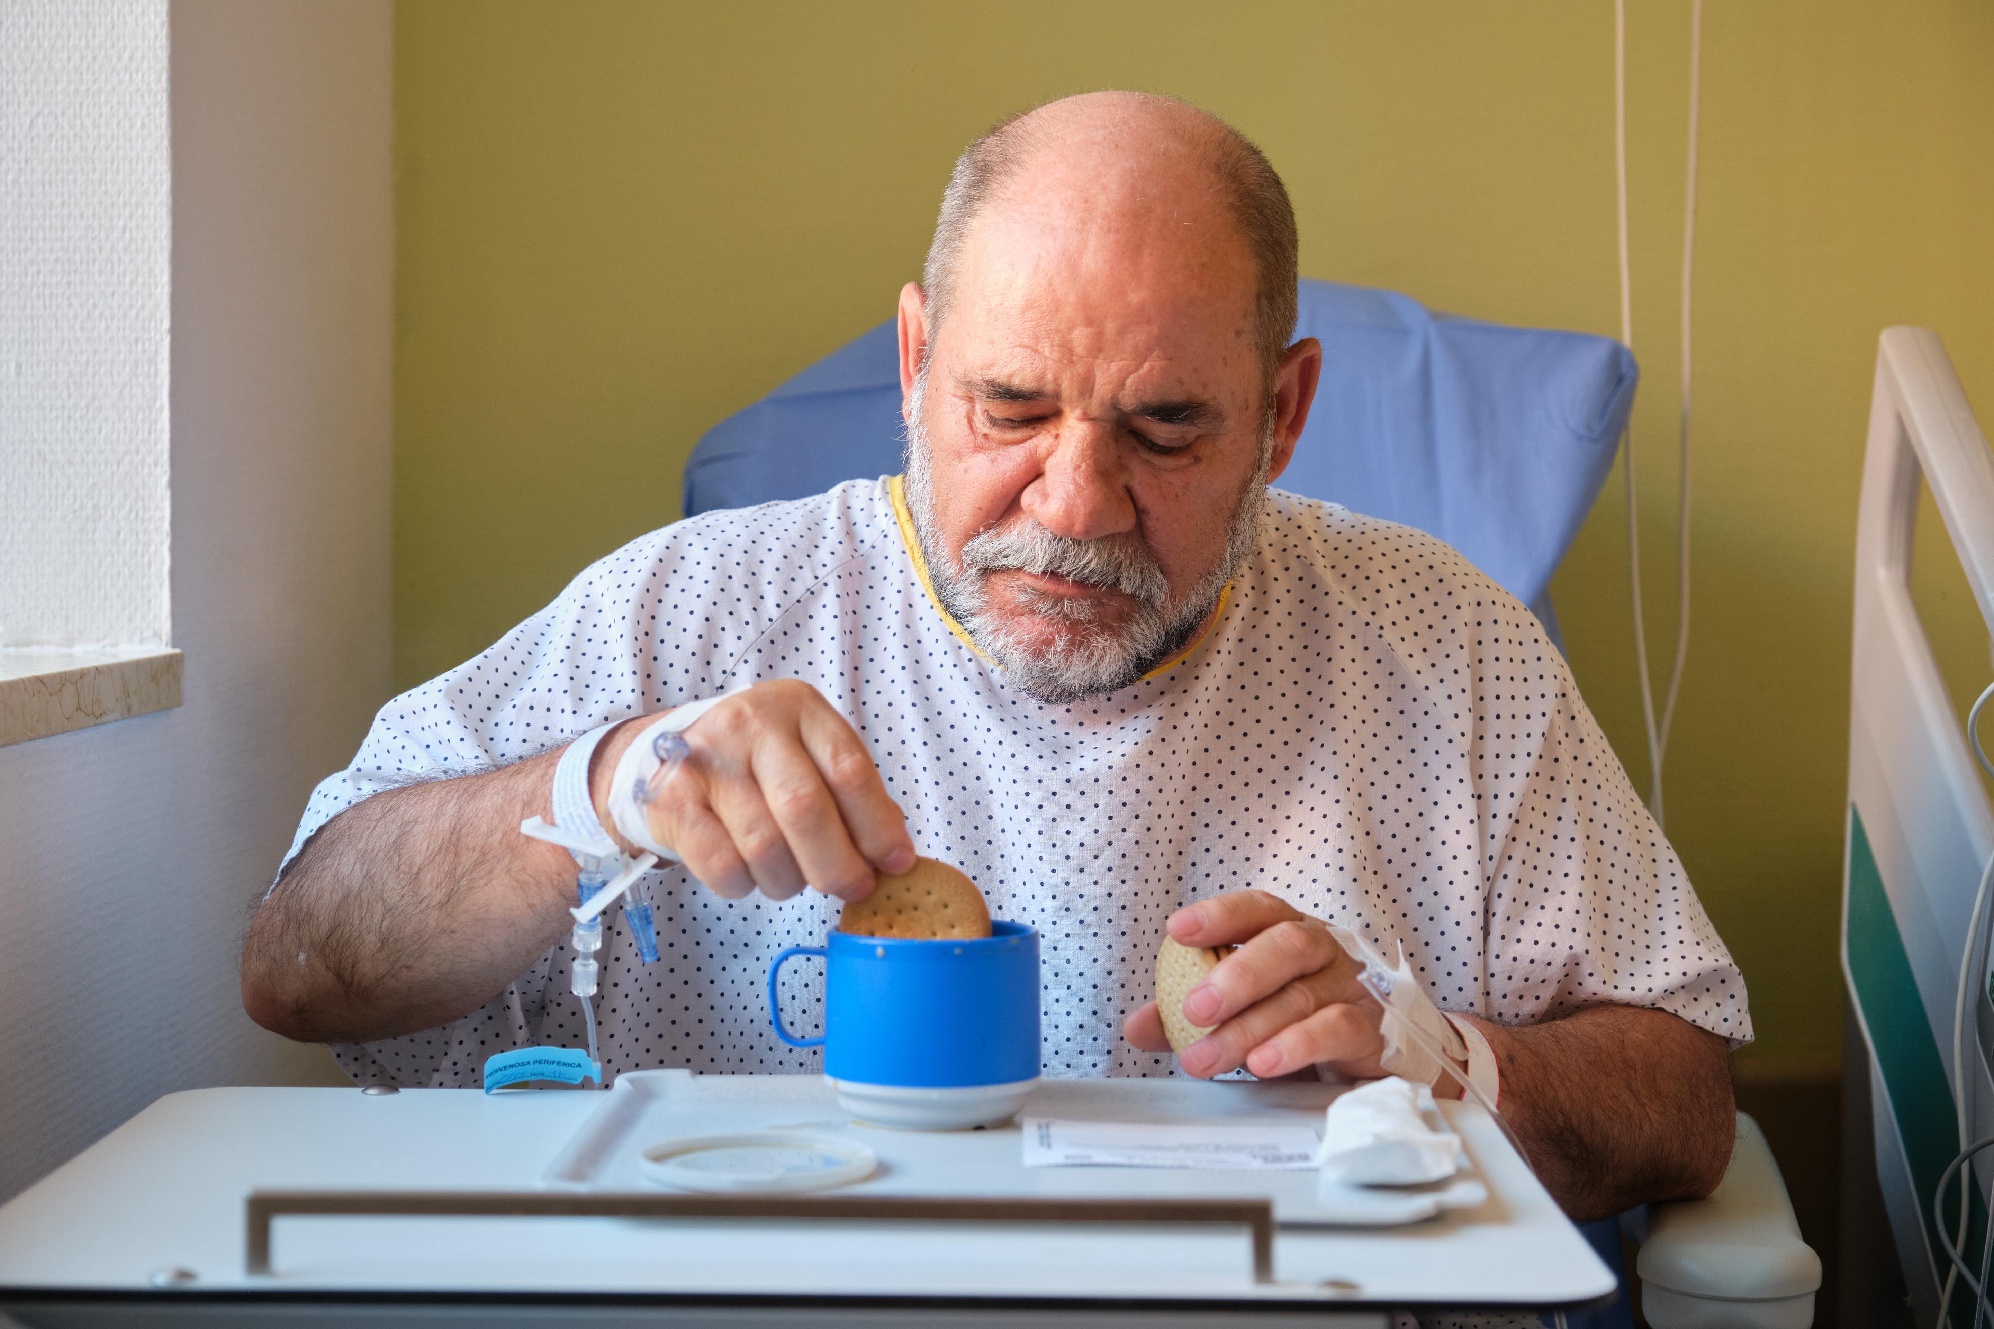
How can I help someone with delirium?
Some of the things below may help.
- Keep calm and speak in short, easy to understand sentences.
- Remind the person with delirium where they are and why they are there.
- Give regular reassurance, don’t argue or disagree.
- Remind them of the date and time and let them know what’s going on. Make sure they can see a clock and a calendar if possible.
- Keep the room well-lit in the day and dark at night.
- Wake people regularly if they are sleeping through the day and encourage them to get up and dressed.
- If the person needs their glasses, hearing aids or dentures, please make sure they have them.
- Offer frequent snacks and drinks – you may need to prompt them much more than you usually would. Ask the nurses if you can help at mealtimes. Bring in favourite food and drink.
- Bring in familiar photos or objects and other items that provide comfort, like favourite music or a warm blanket.
- Reduce noise as this can stimulate the person too much and make things worse.
- Complete a ‘This Is Me’ document, as this will help the team to communicate better with the person you care for and understand their care needs more fully.
- Visit as often as you feel you can. Talk to the nurses about coming outside of visiting hours. Being with the person is likely to be reassuring and help in the treatment of their delirium.
Please talk to the ward staff if you would like any advice about how to support a person with delirium or if you have any concerns, worries or difficulties.
If someone has delirium and is resisting care what will help?
Delirium can be very frightening for the person experiencing it. This can lead to them to behave in ways that is out of character for them. If someone is resisting care, this is likely because they are distressed.
It can help if family or friends sit quietly with the person to help calm them down. If you wish to stay for longer periods with the person, speak to the nurse in charge.
In some cases, it may be necessary to give calming or sedating drugs, especially if the person remains extremely distressed or unsafe because of their delirium after everything else has been tried. If so, the lowest possible dose will be given for the shortest time.
How long does delirium take to get better?
After treating the cause or causes of delirium, most people recover in a few days. However, it can take several weeks or months for some people to recover from an episode of delirium.
Sometimes, people with delirium do not always return to their previous level of mental or physical function. This is more likely if the person is frail or is living with dementia.

What happens when patients leave hospital?

Occasionally, an episode of delirium may be a trigger for revealing an underlying chronic memory problem (or cognitive impairment).
If you or your family notice ongoing memory problems that persist for several weeks after delirium, speak to your GP for advice. Sometimes the hospital clinical team will suggest an assessment at your local memory clinic.
Being in your home environment with familiar people, routines and surroundings that you know is likely to improve recovery. The decision on whether someone can be looked after in their usual environment depends on the cause of delirium, the support available to them at home and the wishes of the patient and caregivers.
The ward team (including the discharge team) will work with you to plan a safe discharge when delirium is taking longer to resolve.
Unfortunately, people who have experienced delirium are more likely to have it again if they become unwell. It is important to be familiar with the signs of delirium and alert your GP, immediately, if you are worried.
Useful resources:
National Institute for Health and Care Excellence (NICE)
Information for people with delirium, carers and those at risk of delirium.
www.nice.org.uk/guidance/cg103
Royal College of Psychiatrists information leaflet:
www.rcpsych.ac.uk/healthadvice/problemsdisorders/delirium.aspx
Delirium is more common in dementia, to read more visit:
www.alzheimers.org.uk
www.dementiauk.org
Need more help?
For support or more information, you can contact:
- Dementia and Delirium Team (King’s College Hospital site) Tel: 020 3299 2478
- Dementia and Delirium Team (PRUH and Orpington sites) Tel: 01689 866975
MyChart
Our MyChart app and website lets you securely access parts of your health record with us, giving you more control over your care. To sign up or for help, call us on 020 3299 4618 or email kings.mychart@nhs.net. To find out more visit www.kch.nhs.uk/mychart
Sharing your information
King’s College Hospital NHS Foundation Trust has partnered with Guy's and St Thomas' NHS Foundation Trust through the King’s Health Partners Academic Health Sciences Centre. We are working together to give our patients the best possible care, so you might find we invite you for appointments at Guy's or St Thomas' hospitals. King’s College Hospital and Guy’s and St Thomas’ NHS Foundation Trusts share an electronic patient record system, which means information about your health record can be accessed safely and securely by health and care staff at both Trusts. For more information visit www.kch.nhs.uk.
Care provided by students
We provide clinical training where our students get practical experience by treating patients. Please tell your doctor or nurse if you do not want students to be involved in your care. Your treatment will not be affected by your decision.
PALS
The Patient Advice and Liaison Service (PALS) is a service that offers support, information and assistance to patients, relatives and visitors. They can also provide help and advice if you have a concern or complaint that staff have not been able to resolve for you. They can also pass on praise or thanks to our teams.
Tel: 020 3299 4618
Email: kings.pals@nhs.net
If you would like the information in this leaflet in a different language or format, please
contact our Interpreting and Accessible Communication Support on 020 3299 4618 or email kings.access@nhs.net

PL393.6 July 2026 Urgent and planned care
Review date July 2029 Comms: 0382

