

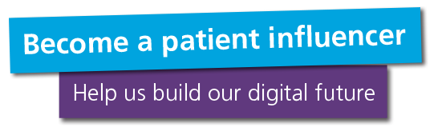**Digital patient panel**

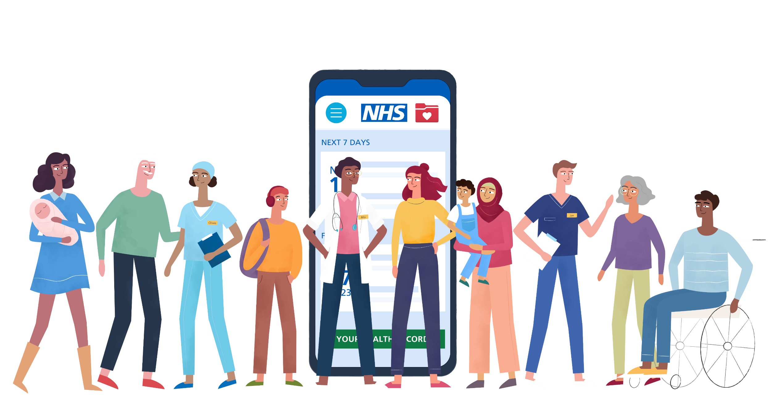

|  |  |
| --- | --- |
| **Position:** | Patient influencer, member of the digital patient panel |
| **Staff contact:** | **General digital patient panel enquiries**: Laura James, lead for patient involvement in digital development (patient and public engagement specialist, Guy’s and St Thomas’ NHS Foundation Trust)  **Project-specific contacts**: these will be shared after you have shown your interest in an activity, and then we have confirmed you are taking part. |
| **Estimated time commitment:** | 0.5 days a month, on average.  This is based on completing one survey and attending one workshop.  Go to the **What will you do?** and **How will we support you in this role?** sections on **page 4** to find out more about the flexibility of this role, and the options available to you. |
| **Preparation time:** | We will give you all the information you need in each activity, but we can send information to you ahead of time if that is helpful. |
| **Length of events and meetings:** | This will depend on the activity, but here are some examples:   * surveys will be around 5 to 10 minutes * workshop meetings are between 1 and 2.5 hours (plus breaks) * other patient panel events will be between 1 and 1.5 hours |

**What is the digital patient panel?**

We know that the best digital healthcare can only be built by working with you – our patients, carers, family members, and anyone else who supports our patients.

Join our panel and make a difference by helping us to design and improve digital services across Guy’s and St Thomas’ and King’s College Hospital NHS Foundation Trusts.

You will help us:

* understand the needs and experiences of people from a wide range of backgrounds
* test digital tools and find ways to make them work better
* design new digital functions and tools
* create clear and accessible supporting information

**Who are we looking for?**

**Digital patient panel members**

All panel members will be 16 or over and will have been a patient or carer of Guy’s and St Thomas’ or King’s College Hospital NHS Foundation Trusts at some point in the last 5 years. This includes accessing services at one or more of the following:

* Guy’s Hospital
* St Thomas’ Hospital
* Royal Brompton Hospital
* Harefield Hospital
* Evelina London Children’s Hospital
* King's College Hospital
* Princess Royal University Hospital
* Beckenham Beacon
* Orpington Hospital
* Queen Mary's Hospital
* Guy’s and St Thomas’ NHS Foundation Trust community services and sexual health services
* King’s College Hospital NHS Foundation Trust community services and sexual health services

We would particularly like to have digital patient panel representation across the following groups:

* people with all levels of digital confidence, from low to high
* over 75s
* people who have English as an additional language
* people who have disabilities, and their carers

Applicants aged 16 and 17 will need written permission from a parent, guardian or carer to take part.

|  |
| --- |
| **Patient influencers**  Patient influencers will have some interest or experience in using digital technology for healthcare. They will also have the ability to:    voice opinions constructively and present views clearly  be objective, fair and transparent in the process of assessing options  bring a patient, parent or carer perspective to discussions and decision making  collaborate effectively as a member of a team |

**What will you do?**

As part of the patient influencer role, you will need to:

* apply to take part in digital patient panel activities when possible
* represent your own views or the views of those you know or care for
* where appropriate, prepare for engagement activities by reading any relevant information provided
* be willing to undertake appropriate training, development and support activities that are offered

**How will we support you in this role?**

* **We offer lots of different opportunities for involvement:** we will contact you with available opportunities. You can then tell us which you would like to take part in.
* **Flexible participation:** you can get involved as much or as little as you want. There will be a mix of online and face-to-face options.
* **Updates on impact:** we will provide updates on how your involvement has made a difference.
* **Career and educational development:** you will get a chance to learn about and take part in digital design processes.
* **Reimbursement of expenses:** we will reimburse your out-of-pocket expenses in line with Trust policy.
* **Support to take part:** we will ask you if there is any additional support you need to get involved

Depending on the type of activity you take part in, you also may be reimbursed and rewarded in one or more of the following ways:

|  |
| --- |
| * public and other types of transport reimbursement * childcare reimbursement * paid carer reimbursement * internet data add-on reimbursement * monetary payment * Foundation Trust membership * job and education references |

If you are successful in applying to take part in a particular activity, we will then let you know which types you can claim for. All reimbursement and reward will be in alignment with Guy’s and St Thomas’ NHS Foundation Trust policy.

**Next steps**

If you are ready to apply, please complete the online application form.

If you would like to have an informal conversation about the role, or request the form in a different format, please contact:

* Laura James, Patient and Public Engagement Specialist (Guy’s and St Thomas’ NHS Foundation Trust)
* T: 07824 364 480
* E: laura.james46@nhs.net