**MOLI FAQs**

**A new option for induction of labour**

Why do we need another way to induce labour?

Some people have fed back that current methods of labour induction can be slow, uncomfortable and are not always successful. This study is looking at a new method of induction to try and improve the current process. Mifepristone has the potential to be better than current induction methods. After mifepristone is given, women can go home and some clinical trials have shown that mifepristone increases the chance of labour starting in the next 48 hours, makes the induction more successful, shortens labour, and lowers the emergency Caesarean rate.

How will the trial test mifepristone as an induction of labour method?

The trial is a randomised control trial. This means that we compare the effect of mifepristone to a placebo. The placebo is identical to mifepristone, but does not contain the active drug. To decide which you will receive, we put your information into a computer, and it decides at random which drug you should have. Neither you, nor the people caring for you, know which drug you have received. Using this approach, we can find out what the true effects of mifepristone are, as this method stops you from being treated differently by your caregivers depending on what treatment you have been given.

Is a randomised control trial safe?

Yes, we can find out what you have been given, placebo or mifepristone, any time of the day or night depending on clinical need.

Is mifepristone used by pregnant women and birthing persons?

In some countries, mifepristone is used routinely to induce labour and in trials to date, over 2,000 people with uncomplicated pregnancies have used mifepristone to induce their labour. These studies have shown that mifepristone is effective and safe, but the number of people in the trials was small so we need more evidence before it can be introduced routinely in the NHS.

Is mifepristone used in the NHS now?

Currently in the NHS, mifepristone is used to induce labour in women who have had a pregnancy loss or who need a medical termination of pregnancy.

Why use mifepristone?

The advantage of mifepristone is that it can be used to induce labour at home, reducing the time you could spend in hospital compared to an inpatient induction of labour. The existing evidence says that mifepristone could:

* Increase the chance of labour starting by 1.5 times within 2 days after it is given
* Make labour shorter
* Reduce the chance of an unsuccessful induction of labour
* Reduce the chance of an emergency Caesarean section

Can I go to the birth centre if I go into labour after mifepristone?

Yes, as long as you and your baby are well, and you remain low risk.

Will I have more vaginal examinations?

You will have one extra vaginal examination before your induction, but because mifepristone increases your chances of going into labour before the induction date and makes both the induction and labour shorter, overall, you will probably have fewer vaginal examinations.

How would mifepristone compare to standard care?

The study is trying to find out whether mifepristone can help induce labour in women with an unfavourable cervix. This means that the cervix is closed. Usually, the first step in an induction in women with a closed cervix is to use prostaglandins (a natural hormone which softens the cervix) or a balloon to open the cervix. Once the cervix is open, we can break the waters. Breaking the waters means puncturing the thin membrane which surrounds the baby and releasing the fluid, the baby doesn’t need the fluid at the end of pregnancy. Just breaking the waters can make labour start, but in those who do not go into labour, we can give a hormone called oxytocin to make labour start.

Mifepristone works by blocking the effect of progesterone which maintains pregnancy by keeping the womb relaxed and the cervix closed.

We give mifepristone 2 days before your induction date. By blocking the effects of progesterone, mifepristone can make the cervix open and the womb contract. Current evidence suggests that within 2 days of giving mifepristone, around 30% of women will be in labour or have delivered. In the remaining 70%, who will still need to be induced, the cervix is more likely to be open. If the cervix is still closed, then the response to prostaglandins is improved so that the time to delivery is shortened.

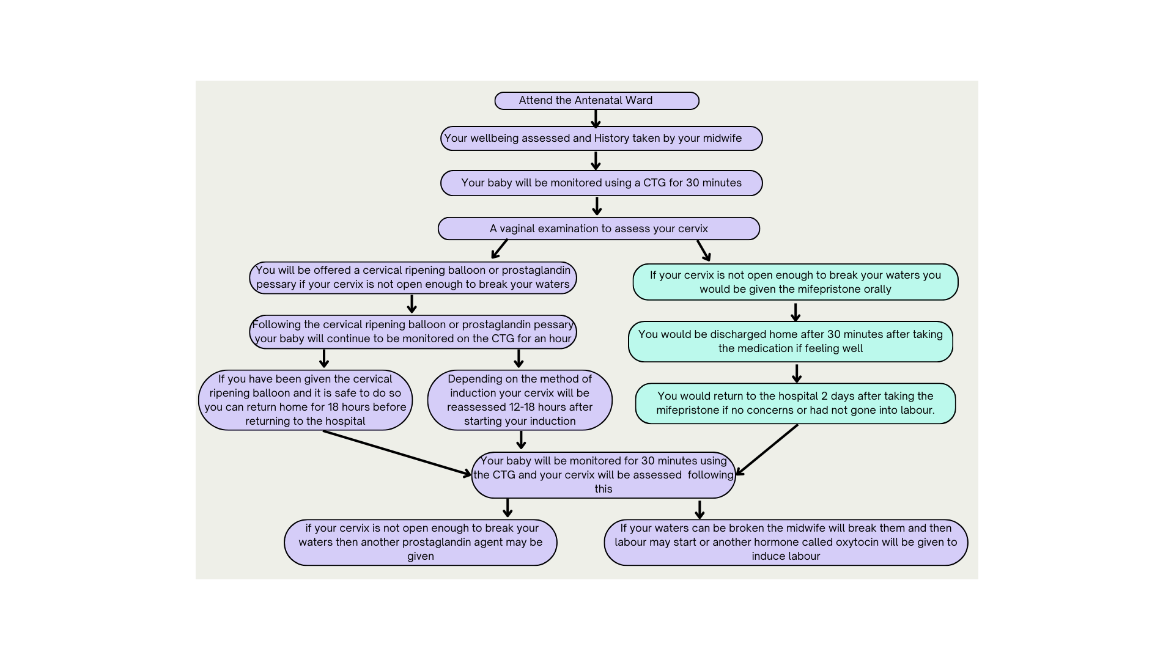

How do the outcomes of induction differ after mifepristone compared to normal?

* The induction will be shorter (36h vs. 53h to delivery in one study)
* The chance of the induction succeeding is 60% higher
* The chance of having a Caesarean section is 23% lower (the average Caesarean section rate after induction is 26%, this would be reduced to 20% with Mifepristone)

Are there any side effects of mifepristone?

Because of the way mifepristone works, it makes the womb more sensitive to the hormones which we might use to induce labour (prostaglandins and oxytocin) increasing the risk of an over-response. If we do give you either prostaglandins or oxytocin, we will monitor you more closely. If we give you prostaglandins, we give you a form that can be quickly removed if you begin to over-respond to it. If we give you oxytocin, we will use a lower dose to start with. Your care team will look after this for you in either case.

Low blood glucose levels occur in 5-15% of normal babies and because of the way that mifepristone acts, it may increase the chance of this happening. Although, this has not been shown to happen in any of the studies so far, to be safe, we will check your babies blood glucose levels twice after birth.