King's College Hospital NHS Foundation Trust patient safety incident response plan – 2023

Effective date: 1st November 2023
Estimated refresh date: 31st December 2024
 | NAME | TITLE | DATE
Author | Andy Wilmer | Associate Director of Patient Safety | 5th October 2023
Reviewer | Róisín Mulvaney | Director of Quality Governance | 30th October 2023
Reviewer | Rantimi Ayodele | Deputy Chief Medical Officer | 30th October 2023
Authoriser | Leonie Penna | Chief Medical Officer – Executive Lead for Patient Safety

Contents
1. Introduction 3
2. Our services 3
2.1. Organisational structure 3
2.2. Clinical services within organisational structure 4
2.3. Geographic Sites 5
3. Defining our patient safety incident profile 6
3.1. Data sources used 6
3.2. Stakeholder engagement 6
3.3. Historic incident investigation demand 6
3.4. KCH patient safety themes 7
3.5. Patient safety incident priorities 12
4. Compassionate engagement 13
4.1. Compassionate engagement flowchart 13
5. Our patient safety incident response plan 14
5.1. National requirements for patient safety incident investigation 14
5.2. National requirements for other external/linked process 14
5.3. Organisational response capacity 15
5.4. Patient safety incident investigation for local priorities 15
5.5. Patient safety incident response selection flowchart 16
5.6. Response types 17
5.6.1. Improvement response 17
5.6.2. Learning response 17
5.6.3. Learning response methodologies 18
5.6.4. Response selection principles 19
5.6.5. Response selection process 19
6. Improvement 21
6.1. Improvement oversight structure 21
6.2. Use of patient safety incident responses to inform improvement 22
6.3. Recording and monitoring improvement 22
6.4. Improvement response improvement flowchart 23
6.5. Learning response improvement flowchart 24
7. Patient safety incident response oversight 25
7.1. Oversight principles and systems 25
7.2. Response completion 25

Introduction
This patient safety incident response plan sets out how King’s College Hospital NHS Foundation Trust intends to respond to patient safety incidents between October 2023 and December 2024 as part of our work to continually improve the quality and safety of the care we provide. The plan is not a permanent rule that cannot be changed. We will remain flexible and consider the specific circumstances in which patient safety issues and incidents occurred and the needs of those affected.

This plan describes how the organisation will focus our resources towards the priorities of;
- Compassionate engagement and involvement of those affected by patient safety incidents to improve the experience for patients, families and staff when a patient safety incident occurs.
- Expanding our insight into system vulnerabilities which create situations where patient harm can occur, and our insight into system factors that support the delivery of safe care, system performance and human wellbeing.
- Using improvement science methodologies to prevent or continuously and measurably reduce repeat patient safety risks and incidents.

This plan should be read in conjunction with the King’s College Hospital NHS Foundation Trust’s Patient Safety Incident Response Policy and NHS Patient Safety Incident Response Framework (2022).

Our services

Organisational structure

Clinical services within organisational structure
We are one of London’s largest and busiest teaching hospitals. We provide a strong profile of local hospital services for people living in the boroughs of Lambeth, Southwark, Lewisham, and Bromley. Our specialist services are also available to patients from a wider area. We provide nationally and internationally recognised treatment and care in liver disease and transplantation, neurosciences, haemato-oncology, and fetal medicine.
Site Executive | Care Group | Patient Safety profile
DH | Acute Speciality Medicine | Falls, pressure ulcers, medication safety, deteriorating patients.
 | Cardiovascular Sciences | Falls, medication safety, deteriorating patients.
 | Emergency Care | Operational safety (capacity), delayed diagnosis, deteriorating patients, medication safety.
 | Liver, Gastroenterology, upper GI, Endoscopy | Falls, medication safety, safer procedures.
 | Neurosciences and Stroke | Falls, medication safety, operational safety (capacity).
 | Planned Medicine | Medication safety, operational safety (appointments, referrals, tracking).
 | Surgery | Operational safety (capacity, appointments, referrals, tracking), medication safety, falls, pressure ulcers, safer procedures.
 | Theatres and Anaesthetics | Safer procedures, operational safety (capacity), medication safety.
 | Children's | Medication safety, deteriorating patients, operational safety (capacity, appointments), maternal & neonatal safety.
 | Critical Care | Pressure ulcers, medication safety, operational safety (capacity).
 | Haematology | Medication safety, falls, operational safety (capacity, appointments).
 | Major Trauma | Medication safety, safer procedures, operational safety (capacity).
 | Pathology | Delayed diagnosis, patient identification, blood transfusion.
 | Pharmacy | Medication safety.
 | Radiology | Radiation protection, delayed diagnosis.
 | Renal and Urology | Operational safety (capacity, appointments), falls, pressure ulcers.
 | Dental | Operational safety (capacity, appointments), safer procedures.
 | Women's Health | Maternal & neonatal safety, safer procedures, deteriorating patients.
PRUH & SS | Adult Medicine | Falls, pressure ulcers, medication safety, deteriorating patients.
 | Cancer | Operational safety (referrals, tracking), medication safety.
 | General Medicine | Falls, pressure ulcers, medication safety, deteriorating patients.
 | Specialty Medicine | Medication safety, operational safety (appointments, referrals, tracking).
 | Orthopaedics | Operational safety (capacity), safer procedures.
 | Ophthalmology | Operational safety (appointments, referrals, tracking), safer procedures.
 | Surgery, Theatres, Anaesthetics & Endoscopy | Operational safety (capacity, appointments, referrals, tracking), safer procedures, pressure ulcers.
 | Therapies, Rehabilitation & Integrated Care Services | Falls, equipment.
 | Medical, Engineering and Physics | Equipment, radiation protection.

Geographic Sites
The Trust operates from multiple sites across South East London, with services further afield across London.
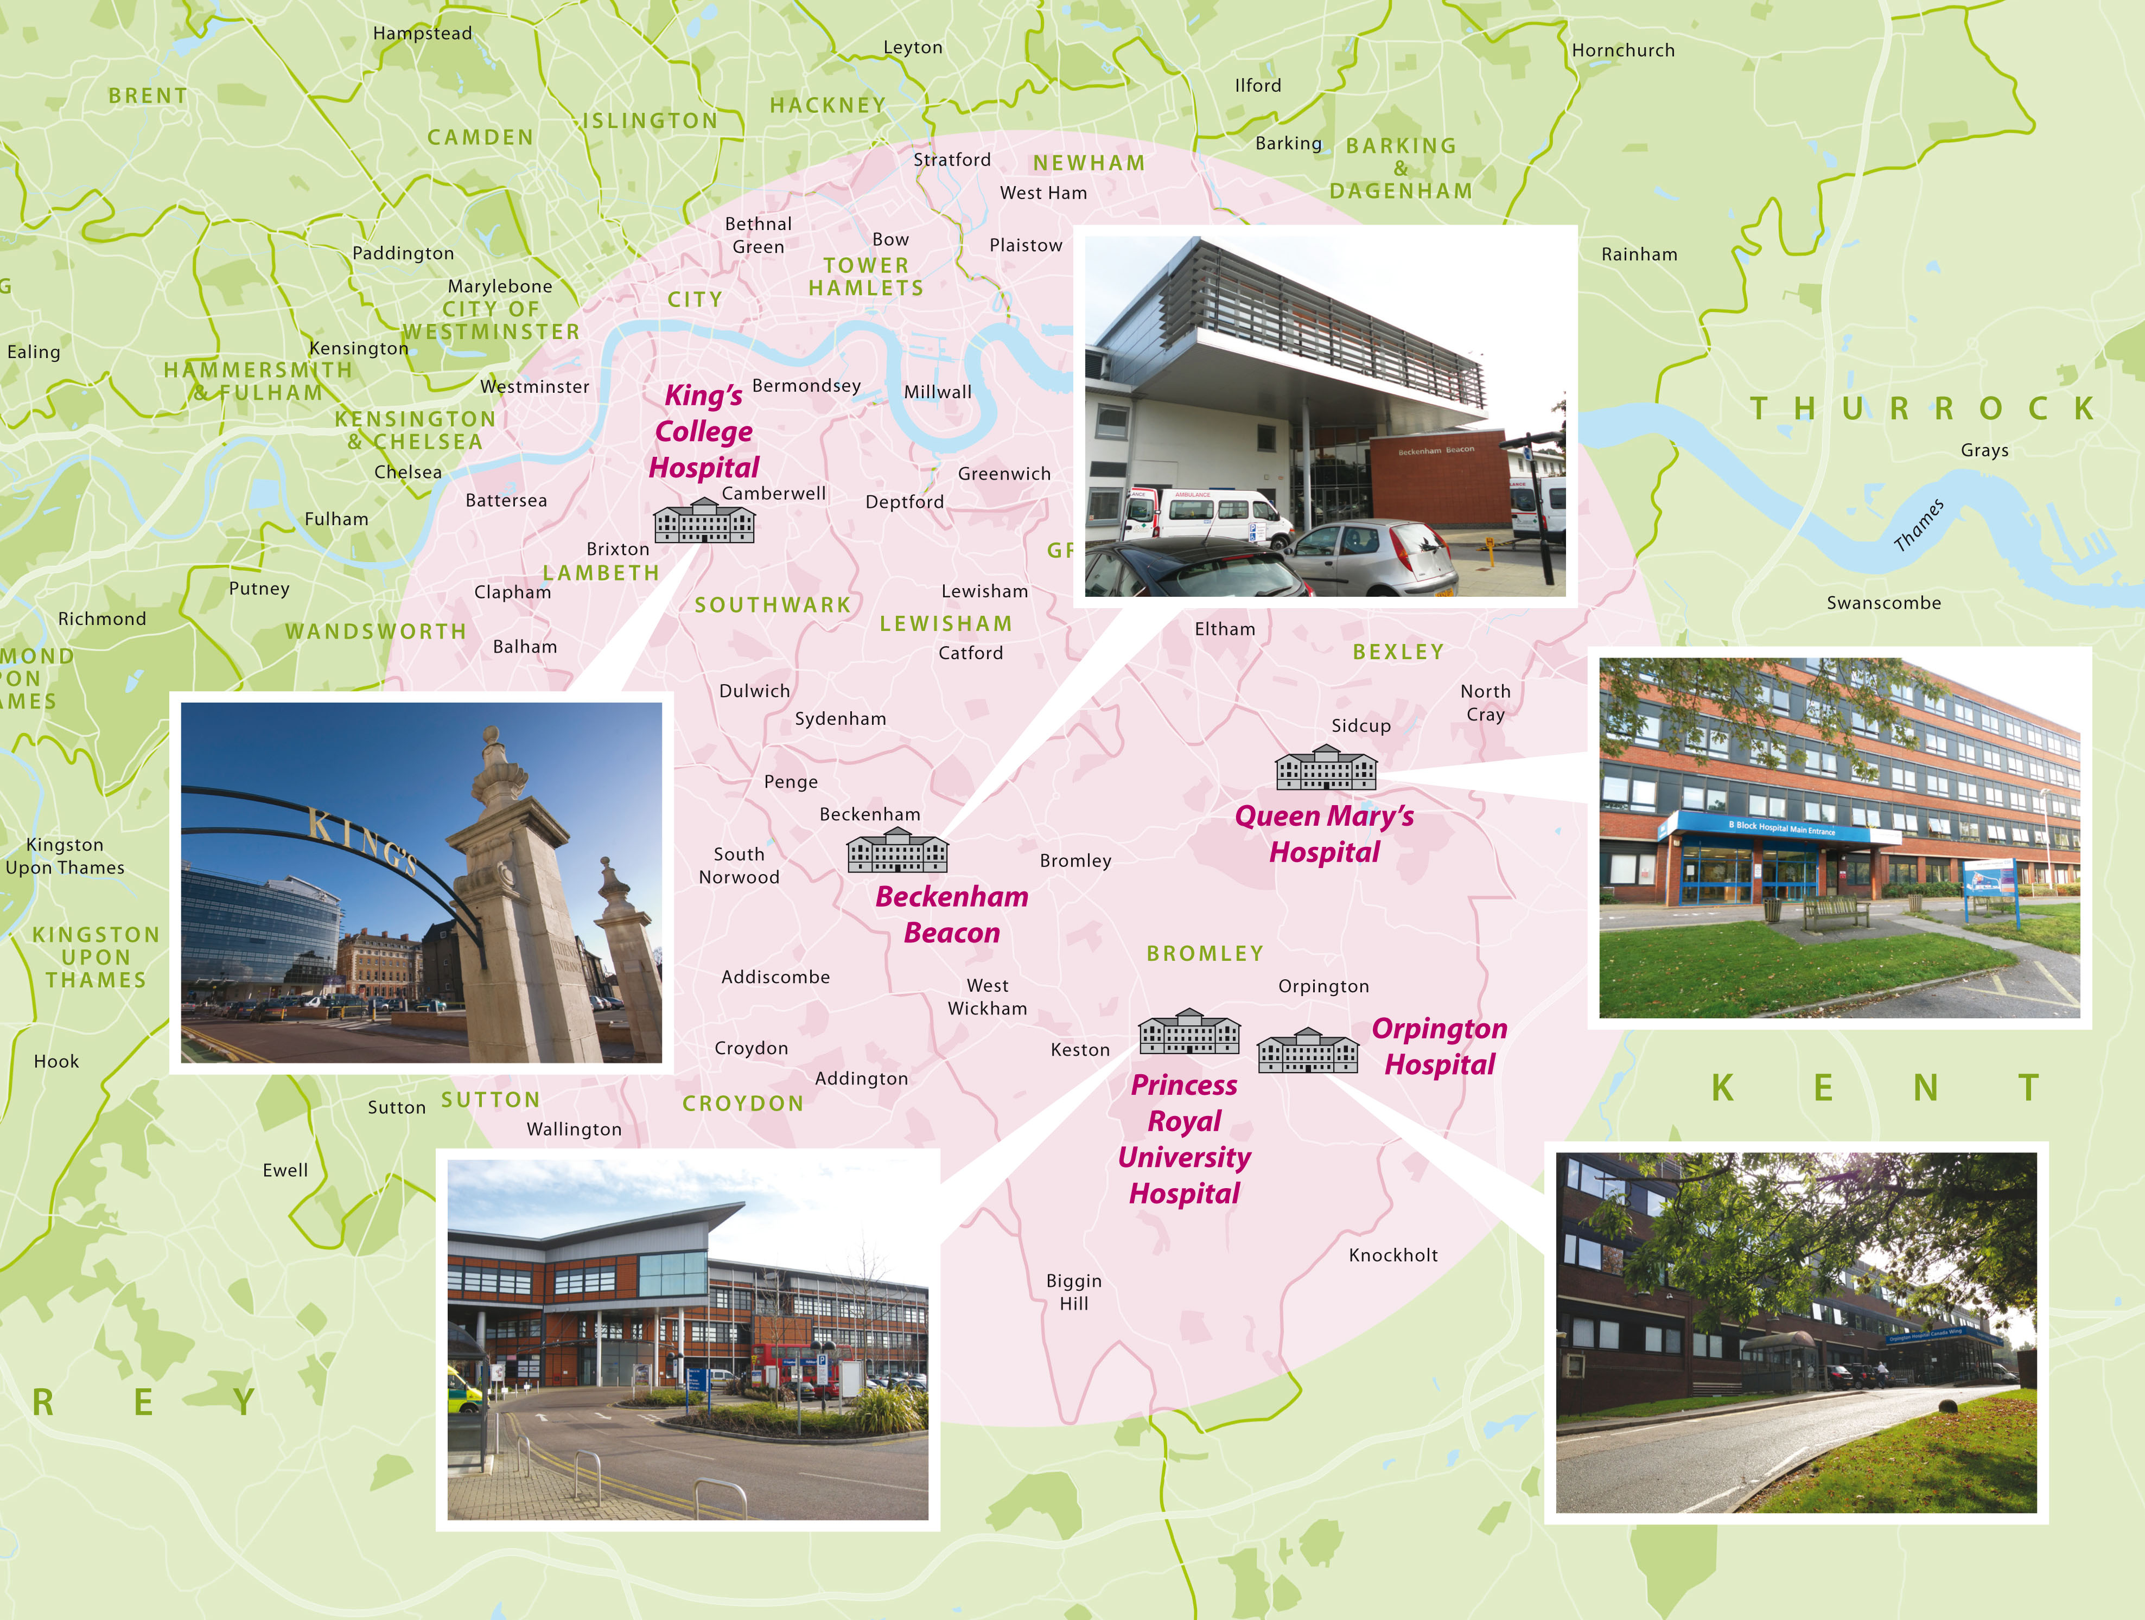

Trust sites include;
- Denmark Hill (King's College Hospital)
- Princess Royal University Hospital
- Orpington Hospital
- Queen Mary's Sidcup (shared with other providers)
- Beckenham Beacon (shared with other providers)
- Satellite sites including renal dialysis units (across South East London), community dental clinics (across South London) and the Havens (across London)

Defining our patient safety incident profile

Data sources used
- Manual analysis of open ‘amber incidents’ and serious incidents as at January 2022 to manually categorise into meaningful patient safety themes, prior to commissioning thematic reviews.
- Thematic reviews completed across all patient safety themes through 2022/23 to triangulate insight across incident data with other quality sources, external sources and an understanding of work as done.
- Data analysis of patient safety incident data between January 2018 and December 2022.
- Review of Serious Incident profile and themes between January 2018 and December 2022.
- Review of NHS National Patient Safety Improvement Programmes, national patient safety challenges within the NHS Learn from Patient Safety Events (LfPSE) service, Healthcare Safety Investigation Branch investigations and NHS Resolution litigation scorecard data.

Stakeholder engagement
- Stakeholder engagement carried out with;
  - Care Group Governance Leads and Partners across the organisation.
  - PSIRF Implementation Steering Group and Working Groups.
  - Site and Care Group leadership teams.
  - Subject matter experts and relevant committees/working groups for patient safety themes identified.
  - External partners across South East London and other partners.

Historic incident investigation demand
 | 2018 | 2019 | 2020 | 2021 | 2022 | Total
Total SIs Declared | 263 | 214 | 137 | 172 | 160 | 946
Total SIs meeting NE Framework | 12 | 6 | 5 | 5 | 5 | 33
Total SIs resulting in Death | 16 | 22 | 19 | 17 | 31 | 105
Total SIs for HSIB Maternity Investigation | 4 | 16 | 13 | 12 | 9 | 54
Total 'amber incidents' | 1021 | 1092 | 1091 | 1268 | 1413 | 5885
Total internal RCA investigations | 1280 | 1290 | 1215 | 1428 | 1564 | 6777
Investigation hours (60 hrs each) | 76800 | 77400 | 72900 | 85680 | 93840 | 406620
Investigation WTE | 2048 | 2064 | 1944 | 2285 | 2502 | 10843

KCH patient safety themes
The information below describes twenty-one patient safety themes (in alphabetical order) with key sub-themes and known insight identified through our safety profile analysis.

This list represents the key types of patient safety themes identified through data analysis of previous patient safety incident reporting, Trust-wide thematic reviews completed in 2022/23, comparison with national patient safety improvement projects and Learn from Patient Safety Events (LFPSE) service themes and stakeholder engagement through various safety, governance, and leadership forums. The themes listed account for 98% of the patient safety incidents analysed above.

Patient Safety Theme | Key Sub-Themes | Key System Insight
Blood Transfusion | Delayed transfusion, use of wrong blood, too much blood used. | Lack of consistent and robust communication/handover processes to support timely administration of prophylactic Anti-D in the antenatal and postnatal period.  Lack of systems to support communication between systems and/or teams of key information (e.g. transplants and their effect on blood groups).  Consistent safety-nets to support accurate blood prescriptions and consideration of special requirements.
Continence and Catheter Care | Catheter-associated urinary tract infections, Trial Without Catheter (TWOC) before discharge, urinary retention. | Absence of preventative strategies to reduce over distention injuries for women postpartum or to intervene in a timely manner.  Kinking of catheters or faulty catheters.
Delayed Diagnosis | Delayed diagnosis of cancer (primarily bowel and lung and generally imaging related), hip fractures, spinal injuries & intracranial bleeds | Handover processes are not always robust, particularly with regards to weekend handovers to follow up diagnostic investigations and results.  Clinical examinations are often rushed due to competing demands, e.g in the ED.
Delayed Treatment | Theatre capacity, access to specialist services, | Capacity to deliver timely treatment (e.g. waiting lists for elective and emergency procedures).  Lack of systems to support communication between systems and/or teams of key information.
Deteriorating Patients | Recognising deterioration, barriers to escalation, sepsis management | Availability of equipment to undertake observations; machines are often broken/ replacements are not available immediately.  The SBAR communication tool is not fully embedded in everyday practice.  Team culture and hierarchy factors can create barriers to escalation to senior clinicians and iMobile.
Discharge Safety | Discharge referrals, discharge medications (to take away) and electronic discharge notifications, booking of appointments at discharge | Discharge summaries often completed by junior staff who are not necessarily familiar with the patient.  Lack of clarity of responsibilities with regards to discharge planning across MDT.  Clinical administrators on wards are extremely effective with discharges, but not all wards are covered consistently.  Multiple IT systems without connectivity, for example social workers have a separate system.  Wards are busy with a lot of distractions. These distractions impact on TTOs and, additionally, ensuring that the patient’s equipment i.e. Zimmer frames, is correctly packed up and goes with the patient.
End of Life Care/Palliative Care | Treatment escalation and resuscitation management, end of life care medications | To be explored
Equipment | Availability/usability of equipment, broken equipment, inter-connectivity of equipment, training to use equipment | There is evidence of machines failing due to a lack of maintenance cover, for example equipment provided via consumable deals, rental arrangements or equipment purchased outside of the standard processes.  New equipment can be purchased in a way that bypasses EBME or MEMS before patient use.  Lack of monitoring of training and competency around the use of medical devices for some staff groups.
Falls | Risk assessments, cohorting/speciality, privacy/dignity/toileting, transfers and handovers, diagnosis of injuries post fall. | Technological system factors identified relate to the duplication of work in falls risk assessments, including the absence of technological prompts to highlight uncompleted/partially completed risk assessments or re-assessments.  Staffing levels impact ability to timely completion of risk assessments, particularly in high acuity/dependency areas and providing enhanced care, particularly in areas with high numbers of patients may be at risk of falls.  The process around imaging, particularly out of hours, and then the communication and/or follow up of results are all areas identified which can contribute to delayed identification of harm associated with the fall.
Infection Control | Hospital acquired infections & line related issues | Inadequate ventilation across most clinical areas, including those caring for high-risk patients.  Operational pressures necessitating frequent movement of patients between wards increases the risks of cross infection and outbreaks.  Older estate limits appropriate bed spacing to promote social distancing.  Damage to fabric of older wards, such as damaged walls and poor fabric, makes it challenge to keep clean.  Variation in Infection prevention & control practice in relation to hand hygiene, PPE use and the decontamination of equipment.
Maternal and Neonatal Safety | Recognition of risk of potential complications in labour or birth, CTG interpretation | Complexity of tasks, particularly instrumental delivery, perennial tear diagnostic and suturing and diagnostic of retained product of conception.  Access to key safety equipment such as episiotomy scissors and CTG machines in theatres
Medication Safety | Insulin safety, anti-epileptic medication, omissions of prescribed medications, air vs O2, heparin management | Complexity of tasks increases risk of harm, particularly related to end-of-life medications, adjustment and titration of anti-coagulation medications and misunderstandings around preparations of opiates.  Handover processes are not always robust when patients are transferred between clinical areas (for example between wards and theatres)  There are insufficient digital safety-nets within the EPMA system to support staff.
Mental Health Safety / Violence and Aggression towards patients | Self-harm/suicide, absconding, restraint, long stays of CAMHS patients in ED | Communication factors between teams, whether between different Trusts, professions or across shift changes or ward moves is highlighted as a system factor regarding the consistency of planned care implementations, patient history, risks and patient triggers.  Not all clinicians have access to LCR (Local Care Record) that would have allowed for other Trusts records to have been viewed.  From a task design perspective, providing 1:1 or cohorting care can fall under the definitions of a “monotonous task” and also one with distractions (for example other competing priorities within the bay and/or on the ward). It can also be difficult to balance patient dignity e.g. when the patient is using the toilet.  Resource factors to provide Enhanced Care relating to sufficient staff, variable ability to fill bank shifts and multiple patients with potential enhanced care requirements on the ward are highlighted.  External environment factors related to social care, primary care and mental health provision leads to a high inpatient demand without capacity. That contributes to delays in transferring patients to the right inpatient beds due to for example delayed discharges both in acute and mental health trusts.
Nutrition & Hydration | Use of NG Tubes, insufficient hydration leading to AKI, choking/SALT guidance | To be explored
Operational Safety | Lost to follow up, referral management, MDM processes | The organisation does not always have robust processes;  - to prevent patients requiring follow up appointment being lost to follow up, particularly in situations where there are no available appointments to book the patient into at the point they leave the clinic.  - to ensure referrals made by/within KCH are received and actioned.  - to ensure appointments/referrals required at discharge are made.  - to ensure appointments or planned admissions cancelled for operational reasons have clinical oversight.  Insufficient capacity across the system leads to delays in treatment.  Reliance on junior/low banded staff to manage key processes without a sufficient understanding of whole system and interconnectivity.
Patient Identification | Positive patient identification | Operational pressures in wards, outpatients and diagnostics restrict appropriate positive patient identification – competing demands between efficiency and thoroughness.  Lack of systems to support positive patient identification for medication safety, diagnostics investigations etc.
Pressure Ulcers | Risk assessments, skin assessments, use of pressure relieving equipment, repositioning, continence management, and nutrition and hydration management. | Similar system/technological factors as per falls were identified regarding tasks, technologies and human capacity to complete Waterlow, MUST etc  There are system barriers to the timely acquisition of pressure relieving equipment.
Results Acknowledgement | Communication of urgent/unexpected findings, acknowledgement of results & categorisation of results (e.g. x-code) | A standardised approach to results acknowledgement is not yet consistently in place across all specialties.  Lack of agreed national principles around which findings should be reported as ‘unexpected significant’, ‘critical’ and ‘urgent’.  Potential cancer findings are not consistently added to Cancer PTL spreadsheet or automatically highlighted with specific cases only escalated via email communication.  EPR results acknowledgement functionality does not cover all diagnostic results.
Safeguarding | Discharging of vulnerable children with unrecognised/unaddressed safeguarding concerns, allegations of abuse by patients, visitor management | To be explored
Safer Procedures | Surgical count issues, Safer Surgical Checklist issues, consent, management of complications, surgical equipment issues | Staff may not regularly work together or may be overfamiliar (this can create variations and workarounds in practice).  Checking procedures are not always completed as work as imagined, particularly when they are repetitive.  Tasks can be interrupted and therefore be incomplete or contribute to errors.  There are competing demands for staff around maintaining flow and operational performance.
VTE | Prescribing/administration of mechanical/chemical prophylaxis post risk assessment. | The organisation has limited systems to prompt the appropriate re-assessment of VTE risk, this is particularly significant when a patient initially has a bleeding risk which resolves during the admission.  Systems are not in place to support or prompt staff to consistently follow a VTE risk assessment with the appropriate prescription.  The organisation does not have embedded systems to highlight missing risk assessments/prescriptions  VTE safety is a symptom of wider organisational safety issues related to ward round processes and their interactions with technology.

Patient safety incident priorities
The following local patient safety incident type priorities identified from the safety profiling work are listed below. Criteria for selection was;
- Incidents commonly occur across Serious Incident or other incidents resulting in significant harm.
- Reduced confidence that the organisation has comprehensive insight into the system factors contributing to the themes, and/or where there is insufficient evidence to demonstrate that improvement work is effectively reducing risk.
It is expected that these priorities will be reviewed significantly through the life of this plan as PSIRF principles and improvement work is carried out.

Priority No. | Patient Safety Incident Type | Speciality
1. | Delays in recognising, escalating or treating deterioration and/or sepsis | All areas, including Maternity
2. | Delays in acknowledging significant diagnostic findings. | All areas, including Maternity
3. | Attempted suicide. | All areas, including Maternity
4. | Delays in diagnosis of hip fractures. | Medical specialties and/or Emergency Care
5. | Omissions/delays in the prescription or administration of critical medications. | All areas, including Maternity
6. | Patients lost to follow up from outpatient services. | Outpatient specialties

Compassionate engagement

Compassionate engagement flowchart
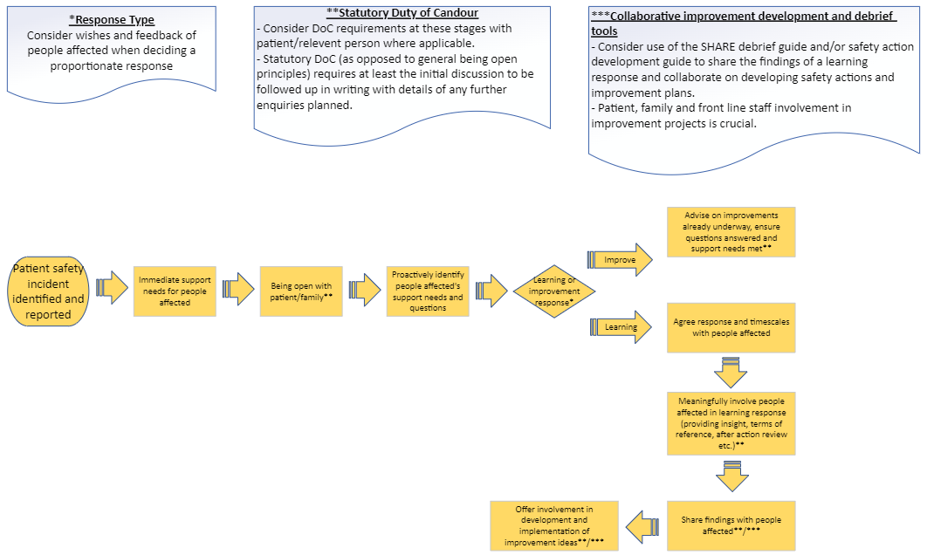

Our patient safety incident response plan

National requirements for patient safety incident investigation
National criteria | Required response | Anticipated improvement route
Incidents meeting the Never Events criteria | Patient Safety Incident Investigation | - Incorporate insight into ongoing improvement plans.  - Develop safety actions or improvement to address new insight and/or emerging safety issues identified.
Death thought more likely than not due to problems in care (learning from deaths criteria)
Maternity and neonatal incidents meeting Maternity and Newborn Safety Investigations (MNSI) programme criteria | Referred to MNSI for independent patient safety incident investigation

National requirements for other external/linked process
Event type | Required response | Anticipated improvement route
Child deaths | Refer for Child Death Overview Panel review. A locally-led PSII (or other response) may be required alongside the panel review – based on discussion with the panel. | - Incorporate insight into ongoing improvement plans.  - Develop safety actions or improvement to address new insight and/or emerging safety issues identified.
Deaths of persons with learning disabilities | Refer for Learning Disability Mortality Review (LeDeR). A locally-led PSII (or other response) may be required alongside LeDeR review – based on discussion with the panel.
Safeguarding incidents (as per PSIRF) | Refer to local authority safeguarding lead.  The organisation will contribute towards domestic independent inquiries, joint targeted area inspections, child safeguarding practice reviews, domestic homicide reviews and any other safeguarding reviews (and inquiries) as required to do so by the local safeguarding partnership (for children) and local safeguarding adults boards.
Incidents in NHS screening programmes | Refer to local screening quality assurance service for consideration of locally-led learning response
Accidental or unintended exposure to ionising radiation | Refer to Ionising Radiation (Medical Exposure) Regulations (IR(ME)R) and reporting requirements.  Consider appropriate and proportionate local response.
Haemovigilance (blood transfusion) | Refer to Serious Hazards of Transfusion (SHOT) guidance and reporting requirements.  Consider appropriate and proportionate local response.

Organisational response capacity
Based on the analysis above it is anticipated that the organisation will be required to undertake the following number of patient safety incident investigations in the following 12 months based on the national requirements above and historic data analysis;
- 6 incidents meeting the Never Events criteria
- 21 incidents meeting the Learning from Deaths criteria

It is anticipated that capacity for patient safety incident investigations will be for 35 investigations over the following 12 months, although this will be kept under review should circumstances change.

Patient safety incident investigation for local priorities
It is planned that that patient safety incident investigations will be undertaken under the duration of this plan for the local priorities above;
Local priority | No. of investigations planned
Delays in recognising, escalating or treating deterioration (all areas, including Maternity) | 2
Delays in acknowledging significant diagnostic findings (all areas, including Maternity) | 2
Attempted suicide (all areas, including Maternity) | 1
Delays in diagnosis of hip fractures (medical specialties and/or emergency care) | 1
Omissions of medications (all areas, including Maternity) | 1
Patients lost to follow up from outpatient services (outpatients) | 1

Patient safety incident response selection flowchart
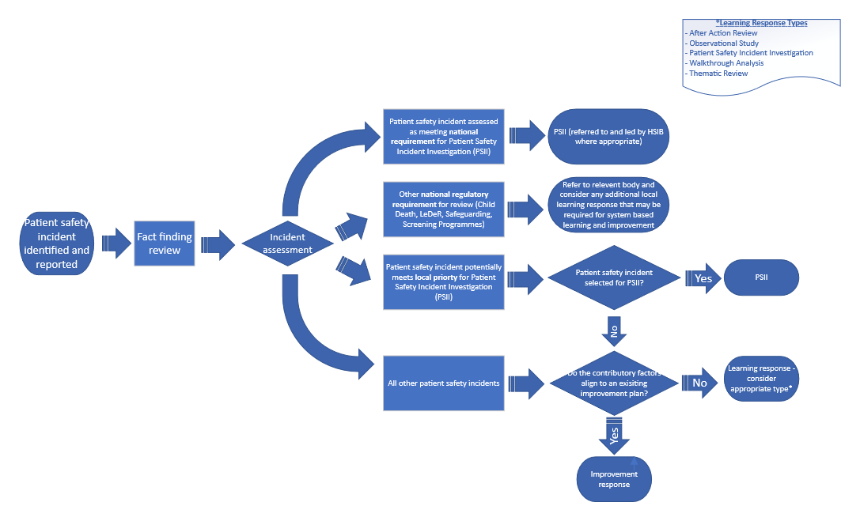

Response types

Improvement response
Where a safety issue or incident type is well understood (e.g. because previous incidents of this type have been thoroughly investigated and national or local improvement plans targeted at contributory factors are being implemented and monitored for effectiveness) resources are better directed at improvement rather than repeat investigation.
In these situations, an ‘improvement response’ is indicated. This still requires compassionate engagement steps to be fulfilled, but no individual learning response to understand the context and underlying system factors.

Learning response
Where contributory factors are not well understood or improvement work is limited in scope of effectiveness, a learning response may be required to fully understand the context and underlying factors that influenced the outcome. A ‘learning response’ covers any system-based methodology and may be used to respond to one or a cluster of patient safety incidents or a wider patient safety theme.

Learning response methodologies
The Trust will primarily use the learning response methodologies listed below. Alternative methodologies may be utilised providing they are system based and developed and conducted in liaison with the Patient Safety Team. Templates to support use of these learning responses are available on InPhase. Outputs of responses should be recorded within the patient safety incident record.
Methodology | Patient safety incident response use | Types of Patient Safety Incidents this response might be appropriate for | Other uses
Patient safety incident investigation (PSII) | For in-depth system-based investigations in line with either;  - national priorities listed above  - local priorities where the incident is selected by the organisation for investigation.  PSIIs may incorporate other additional methodologies to support analysis. | Where a patient safety incident investigation is indicated. | Nil
After action review | Supportive reflection on the work of a group and identifying strengths, weaknesses and areas for improvement. | Incidents within a defined team and relatively short time span (e.g. inpatient medication safety incident, safer procedures) | Learning from good care (appreciative enquiry)
Observational study | To understand work as done rather than work as imagined/prescribed | Any individual or group of incidents. | Learning from everyday work (safety II)
Walkthrough analysis | Process mapping work as done of a process or task. | Task or process related incidents or patient safety themes (e.g. referral management or results acknowledgement) | Proactive risk identification
Thematic Review | Learning from multiple sources of insight into a patient safety issue. | Any patient safety theme | Periodic assessment of known safety themes to identify new insight and/or test effectiveness or improvement activities.

Response selection principles
An appropriate, proportionate response should be selected based on factors including;
- whether the contributary factors are already understood both in general for the type of incident and for the circumstances of the specific event.
- the expected potential for new insight (e.g. a new, emerging, or escalating safety challenge).
- alignment with the local patient safety priorities listed in section 5.4 above.
- whether improvement work is already underway to address the identified contributory factors.
- whether there is evidence that improvement work is having the intended effect/benefit.
- the views of those affected, including patients and their families.
- which type of learning response (or combination of learning response methodologies) will provide the richest insight into the underlying system factors (see table in 5.6.3 above).
- capacity available to undertake a learning response versus the capacity to implement improvement work.

Response selection process
The following process will used to agree a proportionate response, allocate response resource and respond to significant emerging issues where this is the potential for significant new insight;
- First line - response selection made by Care Group
  - Response selection as per plan.
  - A regular Care Group/departmental PSIRF panel is recommended (to be determined by the Care Group/department based on their safety profile, capacity and expected volume of incidents)
- Second line - Site Executive oversight
  - Bi-weekly Site Executive PSIRF panel to review;
    - All patient safety incidents potentially meeting national requirements (NE, Death, MNSI) for patient safety incident investigation.
    - Patient safety incidents escalated by Care Groups where;
      - the most proportionate response is not clear
      - a patient safety incident investigation may be indicated based on local priorities and/or significant potential for new insight
      - collaboration between different Care Groups, Sites or Providers is required.
    - All patient safety incidents resulting in moderate or severe physical or psychological harm, or death to ensure;
      - Clear plan for response is in place
      - Compassionate engagement lead(s) are in place to support patients, families and staff affected, including fulfilling Duty of Candour requirements.
- Third line – Trust Executive oversight;
  - Recommendations for responses requiring either a patient safety incident investigations or other cross-system response made by a Site Executive PSIRF panel to be considered by the Executive Lead for Patient Safety, other relevant Executives and Patient Safety Specialists for a final decision to commission and/or facilitate.

Improvement

Improvement oversight structure

Patient Safety Theme |  | Improvement group overseeing improvement delivery and effectiveness
1. | Blood Transfusion | Blood Transfusion Committee
2. | Delayed Diagnosis | To be established
3. | Deteriorating Patients | Deteriorating Patients Improvement Group
4. | Discharge Safety | To be established
5. | End of Life Care/Palliative Care | End of Life Care Committee
6. | Equipment | Medical Devices Committee
7. | Falls | Harm Free Care
8. | Infection Control | Infection Control Committee
9. | Maternal and Neonatal Safety | Maternity and Neonatal Quality and Safety Meeting
10. | Medication Safety | Medication Safety Committee
11. | Mental Health Safety | Mental Health Governance Committee & Reducing Significant Restraint Group
12. | Nutrition & Hydration | Nutrition Steering Group
13. | Operational Safety | To be established
14. | Pressure Ulcers | Harm Free Care
15. | Results Acknowledgement | Diagnostic and Clinical Results Improvement Group
16. | Safeguarding | Safeguarding Committee
17. | Safer Procedures | Safer Procedures Improvement Group
18. | VTE | VTE Committee

Use of patient safety incident responses to inform improvement
Patient safety incident responses will be used to;
- Develop safety actions where a system-based solution to an issue is evident.
- Develop Care Group patient safety improvement plans for Care Group patient safety priorities.
- Develop Trustwide patient safety improvement plans via Trustwide safety improvement groups.
- Develop system-wide patient safety improvement actions in collaboration with system partners across the region and clinical networks.
- Inform the development and effectiveness of ongoing local and Trustwide quality improvement work.

Response and oversight leads will collaborate on the development of improvement plans and safety actions with people affected and other patient representatives and frontline staff. The SHARE debrief guide and safety action development guide are recommended for supporting the sharing of insight gained through a learning response and the collaborative development of improvement ideas.

Improvement plans to improve patient safety should be developed utilising insight from responding to patient safety incidents, triangulated with a wide range of sources of insight as per the Trust’s Patient Safety Incident Response Policy.

Tools and coaching to design and deliver improvement plans can be accessed via the Quality Improvement Team. This includes scale and spread methodologies such as the IHI Collaborative methodology where the required improvement solution is already known.

Recording and monitoring improvement
Safety actions should be recorded within the Trust’s incident management system to facilitate local monitoring of their implementation and effectiveness.

Improvement plans will be developed and held at the relevant level within the organisation (or wider) normally at Care Group, Trustwide Improvement Group level.

Improvement response improvement flowchart
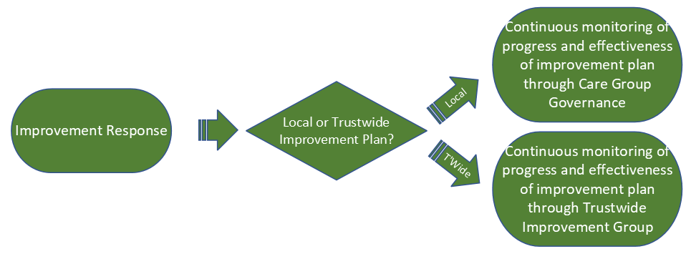

Learning response improvement flowchart

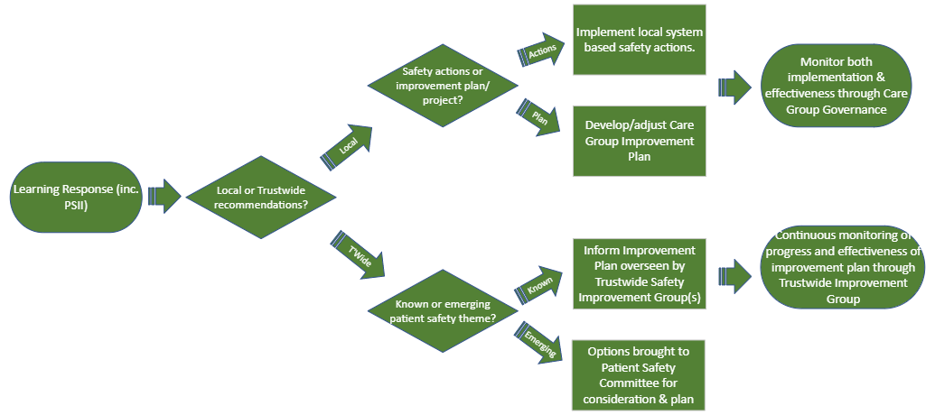

Patient safety incident response oversight

Oversight principles and systems
Oversight principles and systems as set out in the Patient Safety Incident Policy will be followed. Oversight processes will focus on the spirit of PSIRF through;
- ensuring responses have compassionately engaged and supported people affected and learning responses have been proportionate and system based in both their findings and recommendations.
- focusing attention and resources on the delivery of effective improvement activities to address system factors
- supporting collaboration on both insight and improvement activities
- being curious to understand the safety of the system through multiple sources and approaches.

Response completion
The response should be recorded as ‘response complete’ within the incident management system when the following steps have been completed in the table below;

Response Type | Methodology | Incident response | Compassionate engagement | Oversight
Improvement response | n/a | - Confirmed contributory factors already understood and effective improvement plan in place. | - Being open [and DoC where applicable] completed with people affected.  - Support needs and questions proactively sought and resolved. | - Plan for continuous monitoring of effectiveness of improvement plan in place.  - Any obvious local safety actions implemented.  - Processes to monitor effective selection of response, compassionate engagement, and effectiveness of improvement in place.
Learning response | Patient Safety Incident Investigation | - Learning response completed as per guidance and system insight recorded. | - Being open [and DoC where applicable] completed with people affected.  - Support needs and questions proactively sought and resolved.  - People affected actively engaged in the response.  - System findings shared.  - Collaboration with people affected on improvement ideas. | - PSII reviewed and signed off by Exec Lead.  - Insight used to generate local safety actions and/or inform wider improvement plans.  - Plan for continuous monitoring of effectiveness of improvement plan in place.  - Collaboration with internal and external partners on improvement as required.
 | After Action Review |  |  | - Insight used to generate local safety actions and/or inform wider improvement plans.  - Response reviewed by relevant oversight lead/governance meeting to ensure response was proportionate and system based, compassionate engagement principles followed  - Process to monitor effectiveness of improvement in place.
 | Observational Study
 | Walkthrough Analysis
 | Thematic Review |  |  | - Group commissioning review receives final report and uses insight to inform improvement plans.  - Plan for continuous monitoring of effectiveness of improvement plan in place.
Table 1 - Patient safety incident response standards

