**King's College Hospital NHS Foundation Trust patient safety incident response plan – 2025-2026**

Effective date: 1st August 2025

Estimated refresh date: 31st December 2026

|  |  |  |  |
| --- | --- | --- | --- |
|  | **NAME** | **TITLE** | **DATE** |
| **Author** | Andy Wilmer | Associate Director of Patient Safety | 28th May 2025 |
| **Reviewer** | Róisín Mulvaney | Director of Quality Governance | 30th May 2025 |
| **Reviewer** | Paul Donohoe | Associate Medical Director (Risk and Governance) | 30th May 2025 |
| **Reviewer** | Multiple | Patient Safety Specialists | 30th May 2025 |
| **Reviewer** | Patient Safety Committee | All Committee members | 30th May 2025 |
| **Reviewer** | Quality Committee | All Committee members | 19th June 2025 |
| **Authoriser** | Mamta Shetty Vaidya | Chief Medical Officer – Executive Lead for Patient Safety | 17th July 2025 |
| **Authoriser** | Trust Board | All Board members | 17th July 2025 |

Contents

1. Introduction 3

2. Changes since our last Patient Safety Incident Response Plan 3

3. Our services 3

3.1. Introduction 3

3.2. Organisational structure 5

3.3. Geographic Sites 6

4. Our patient safety profile and priorities 7

4.1. Approaches to defining our patient safety incident profile and priorities 7

4.2. Other approaches to inform the development of this plan 7

4.3. Organisation system vulnerabilities 8

4.6. Trustwide patient safety improvement priorities 11

4.7. Local patient safety incident investigation priorities 15

5. Compassionate engagement 16

5.1. Compassionate engagement principles 16

5.2. Compassionate engagement processes 16

5.3. Compassionate engagement flowchart 17

6. Our patient safety incident response plan 18

6.1. National requirements for patient safety incident investigation 18

6.2. National requirements for other external/linked process 18

6.3. Historic investigation and learning response demand 19

6.4. Expected learning response and patient safety incident investigation demand 19

6.5. Organisational patient safety incident response capacity 20

6.6. Patient safety incident response selection 21

6.6.1. Patient safety incident response selection flowchart 21

6.7. Response types 22

6.7.1. Learning response 22

6.7.2. Improvement response 22

6.7.3. Learning response methodologies 23

6.7.4. Response selection principles 24

6.7.5. Collaborative working 24

6.7.6. Proportionate response decision making process 25

7. Improvement 28

7.1. Improvement oversight structure 28

7.2. Other patient safety improvement groups and workstreams, including Transformation Programmes 29

7.3. Use of patient safety incident learning responses to inform improvement 29

7.4. Other improvement activities 30

7.5. Recording and monitoring improvement 31

8. Patient safety incident response oversight 32

8.1. Oversight principles and systems 32

8.2. Response completion 32

# Introduction

This patient safety incident response plan sets out how King’s College Hospital NHS Foundation Trust intends to respond to patient safety incidents between June 2025 and December 2026 as part of our work to continually improve the quality and safety of the care we provide. The plan is not a permanent rule that cannot be changed. We will remain flexible and consider the specific circumstances in which patient safety issues and incidents occurred and the needs of those affected.

This plan describes how the organisation will focus our resources towards the priorities of;

* Compassionate engagement and involvement of those affected by patient safety incidents to improve the experience for patients, families and staff when a patient safety incident occurs.
* Delivering effective and sustainable improvements in patient safety.
* Developing insight into the working of the system in which our staff deliver and our patient’s receive care, where this insight is not already available.

This plan should be read in conjunction with the King’s College Hospital NHS Foundation Trust’s Patient Safety Incident Response Policy (2023) and NHS Patient Safety Incident Response Framework (2022).

# Changes since our last Patient Safety Incident Response Plan

The key changes to the Trust’s plan since our first plan in 2023 are;

* The focusing of efforts and resources on to four patient safety priorities for improvement.
* Changes to our local priorities for patient safety incident investigations.
* The incorporation of MDT Review as a system-based learning response methodology in the place of Thematic Reviews to increase the proportionality of responses.
* The removal of Site level PSIRF Panels to reduce duplication and improve sharing of learning.

This is based on an evaluation of our initial PSIRP towards the end of 2024, and the areas for improvement identified.

# Our services

## Introduction

We are one of London’s largest and busiest teaching hospitals. We provide a strong profile of local hospital services for people living in the boroughs of Lambeth, Southwark, Lewisham, and Bromley. Our specialist services are also available to patients from a wider area. We provide nationally and internationally recognised treatment and care in liver disease and transplantation, neurosciences, haemato-oncology, and fetal medicine.

## Organisational structure

## Geographic Sites

The Trust operates from multiple sites across South East London, with services further afield across London.

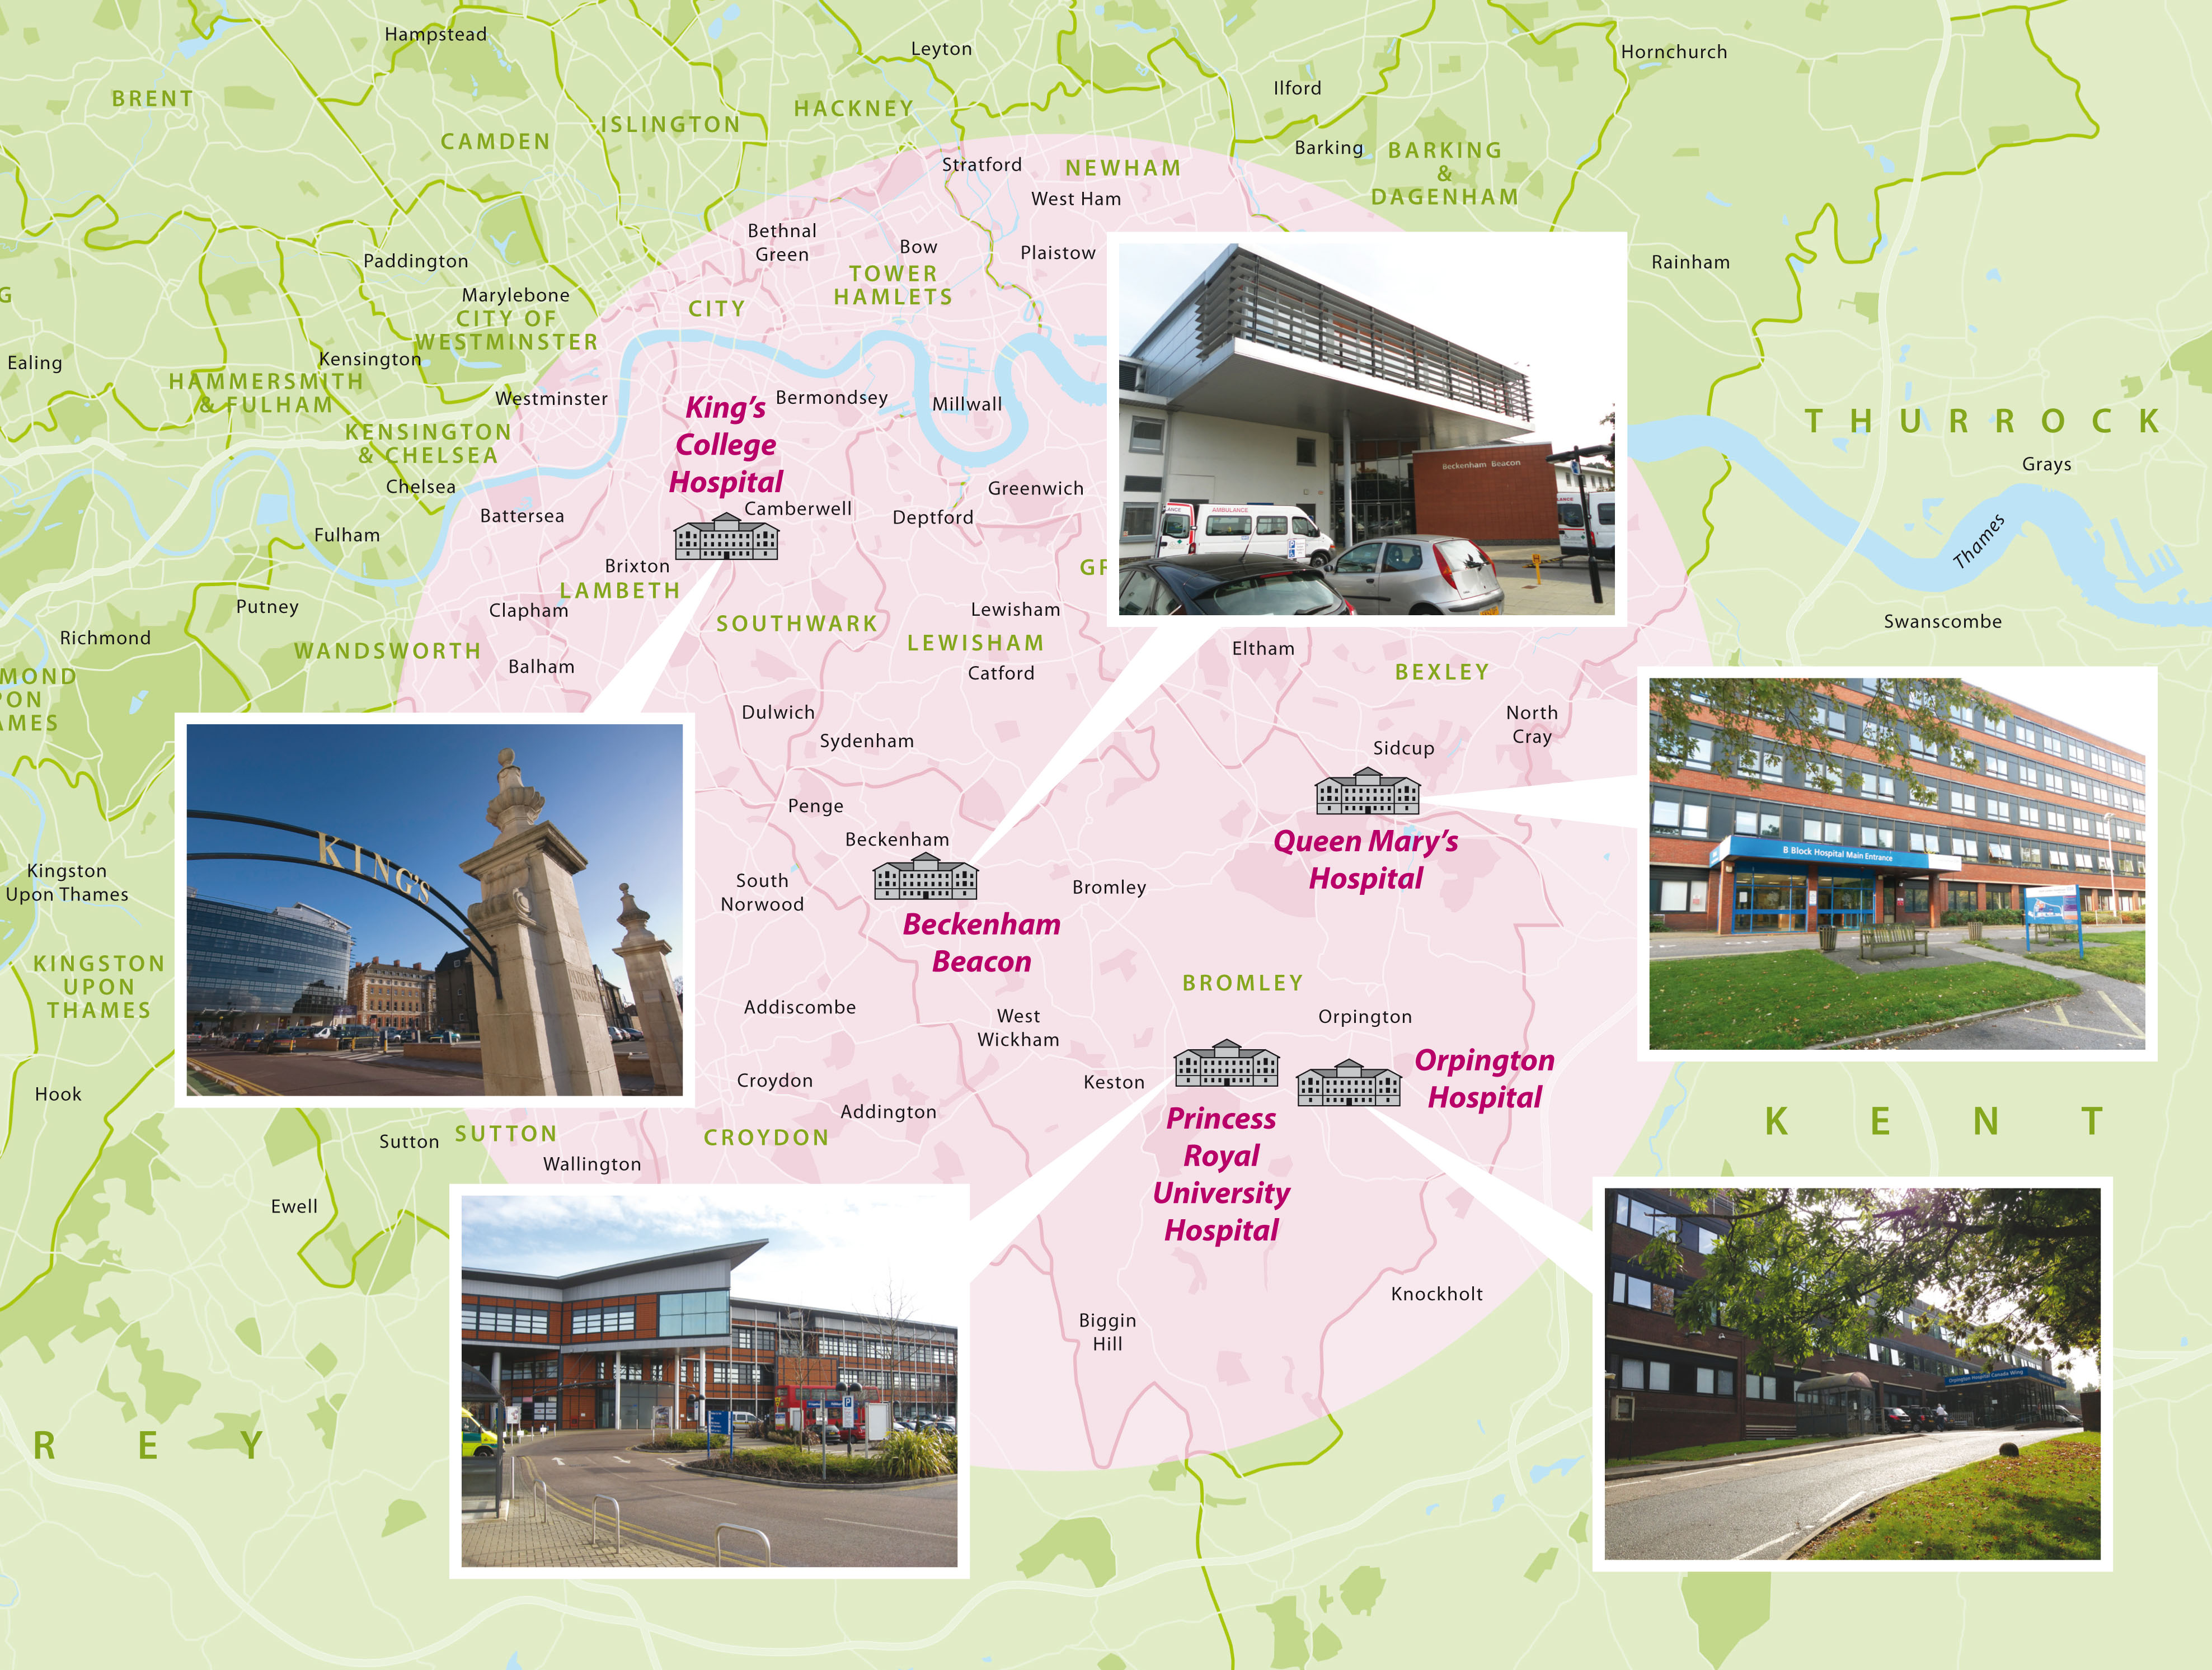

The Trust is registered with the Care Quality Commission to provide services in the following locations:

* King's College Hospital
* Princess Royal University Hospital
* Orpington Hospital
* Queen Mary's Sidcup
* Beckenham Beacon
* Satellite units and services including;
  + Camberwell Hub.
  + Tessa Jowell Heath Centre.
  + Renal Dialysis Satellite Units across South East London.
  + Community special care dentistry across South East and South West.
  + Havens sexual assault referral centres in Camberwell, Paddington and Whitechapel.

# Our patient safety profile and priorities

## Approaches to defining our patient safety incident profile and priorities

Our insight into patient safety challenges has improved since the data profiling carried out for our first plan. Since our initial plan was published, we have the benefit of hundreds of system-based learning responses, two years’ worth of data from the learn from patient safety events (LFPSE) service, amongst other insight sources and incorporation of systems-thinking across all our patient safety activities.

Our patient safety incident profile, and therefore our priorities for both improvement and local patient safety incident investigations was based on;

* A weighted, aggregated data analysis of the following sources;
  + Themes, level of harm and level of concern from over 30000 patient safety incidents reported between February 2024 and February 2025.
  + Themes associated with 28 commissioned patient safety incident investigations between November 2023 and April 2025.
  + Themes linked to 365 patient safety related entries on the Trust’s risk register
  + Themes and value of claims across 96 patient safety related claims from the NHS Resolution litigation scorecard data from January 2022 to March 2025.
  + Themes from 1200 patient safety related patient complaints from April 2024 to April 2025.
  + Trust agreed Quality Account priorities for 2025/26.
* Triangulation with the following external or national sources;
  + National patient safety priorities of NHS England
  + Published priorities of the Patient Safety Commissioner
  + National patient safety alerts
  + Healthcare Safety Investigation Branch investigations
* An aggregated thematic analysis of 560 completed learning responses to understand common contributory factors and recommendations based on the System Engineering Imitative for Patient Safety (SEIPS) framework.[1]
* Stakeholder engagement with internal and external subject matter experts and stakeholders.

## Other approaches to inform the development of this plan

* Participation in a South East London Integrated Care System PSIRP workshop with external evaluation of existing plans.
* Review of published PSIRPs across South East London and Shelford Group Trusts[2] to identify ideas and best practice.
* Recommendations from Patient Safety Learnings review of PSIRPs.[3]
* Recommendations from Imperial’s review of Patient Safety in 2024.[4]

## Organisation system vulnerabilities

An aggregated analysis of more than 550 learning responses identified these common contributory factors and recommendations;

|  |  |  |
| --- | --- | --- |
| System Factor | Common contributory factors | Common recommendations for improvement |
| Person factors | Patients unable to advocate for their own safety.  The challenges presented to staff by multiple competing demands.  Human factors such as cognitive biases.  Stress, exhaustion, distractions | Improving how information is shared with patients and families.  Projects addressing specific patient groups' needs (e.g., frailty, women with cancer, etc.).  Improvements in processes to reduce reliance on individual members of staff. |
| Task factors | Lack of standardised processes - reliance on verbal or ad-hoc systems that lead to variability.  Barriers to the escalation of deteriorating patients and/or timely response to escalation. | Structured handover tools (SBAR, digital handovers).  Clear criteria and pathways for escalation. |
| Tools and technology factors | EPIC – disruptions to workflows and processes related to EPIC, particularly around transition, including interface of EPIC with other tasks, such as taking samples or administering medication.  Absence of standardised tools like checklists or proformas.  Limited availability of working equipment/devices. | EPIC optimisation and training for staff. Customization of EPIC to fit workflows (e.g., creating order sets or alerts). Reporting system bugs or limitations and escalating for IT fixes.  Ensuring clinical staff input into digital tool design.  Development of proformas, checklists, or SOPs.  Templates for clinical documentation (e.g., consent forms, escalation pathways).  Embedding best practices into daily workflows. |
| Environment factors | Internal environmental factors that create barriers to undertaking tasks (e.g. ward layouts hindering observing patients effectively, lighting in clinic rooms for minor procedures, barcode medication administration) or create risks (e.g. lack of isolation rooms). |  |
| Organisational factors | Pathway issues including complex pathways and issues with ownership across multidisciplinary teams.  Staffing shortages or overworked staff.  Training - staff unfamiliar with new systems, procedures, or policies. Training not keeping pace with changes in systems or pathways.  Capacity to meet demand. | Multidisciplinary team (MDT) meetings and better information sharing.  Clear role definitions for complex or multi-team care.  Induction refreshers and skill updates for junior staff.  Targeted teaching sessions after incidents or audits. |
| External factors | National workforce shortages.  External capacity constraints (mental health, social care etc.)  Vulnerabilities at interfaces between organisations. | External escalation of challenges |
| General |  | Regular safety audits and review of key incidents.  Feedback loops to share findings and improvement actions with teams and more widely. |

* 1. Divisional safety profile

|  |  |
| --- | --- |
| Division | Patient Safety profile |
| Division A | * Maternity and neonatal safety * Delayed diagnosis * Medication safety |
| Division B | * Falls * Pressure Ulcers * Operational safety – patient flow, boarding, crowding, discharge safety * Medication safety |
| Division C | * Safer procedures * Operational safety – patient flow, boarding, crowding, discharge safety * Medication safety |
| PRUH & South Sites Hospital Team | * Operational safety – patient flow, boarding, crowding, discharge safety |
| Denmark Hill Hospital Team |
| Corporate Services | * Estates/facilities safety * IT systems and software * Discharge safety * Medication safety |

* 1. Geographic safety profile

|  |  |
| --- | --- |
| Division | Patient Safety profile |
| Denmark Hill | * Medication safety * Operational safety – patient flow, boarding, crowding, discharge safety * Delayed diagnosis * Falls |
| Princess Royal University Hospital | * Operational safety – patient flow, boarding, crowding, discharge safety * Medication safety * Pressure ulcers * Falls |
| Orpington Hospital | * Operational safety * Falls * Safer procedures * Discharge safety |
| Queen Mary’s Hospital | * Operational safety – referral management, appointment booking and patient tracking * Delayed diagnosis * IT systems and software |
| Beckenham Beacon | * Delayed diagnosis * IT systems and software * Medication safety |
| Other satellite areas   * Renal satellite units * Havens * Community Dental * Tessa Jowell | * Estates/facilities safety * IT systems and software * Delayed diagnosis * Device safety |

## Trustwide patient safety improvement priorities

Based on the patient safety profiling work detailed above, the following priorities for improvement have been agreed. These areas represent key themes across multiple data sets, but also where we already have good insight into system contributory factors.

|  |  |  |  |  |
| --- | --- | --- | --- | --- |
| Improvement priority & group | Definition | Rationale for prioritisation | Known contributory factors | Current improvement focus |
| Delayed diagnosis   * Delayed diagnosis improvement group * Diagnostic & Clinical Results Improvement Group | Patient safety incidents relating to issues which could or have delayed teams in making a clinical diagnosis for a patient. | * Joint fourth most reported theme in patient safety incident reporting (c. 2800 in the period). * This includes around two hundred patient safety incidents resulting in significant harm, by a distance the theme associated with the highest volume of harm. * Rated 16 on the Trust’s risk register (joint 2nd highest patient safety risk) and the theme with the second highest number of safety related risks. * A theme in 4 patient safety incident investigations commissioned, and over 100 other learning responses. * The theme with the highest number of safety related claims, and the second highest value of claims (behind maternity). * The theme with the highest number of safety related patient complaints. | There are multiple system factors which could contribute to delays in diagnosing fractured neck of femurs. | Quality improvement project focused on #NOF improvement. |
| Diagnoses that could be made by radiology imaging may be missed on reporting due to a variety of system factors. | Quality improvement project focused on radiology reporting. |
| There are system vulnerabilities in the processes between taking samples or specimens in clinical areas, transferring the to the laboratory and receiving a result. | Collaborative improvement plan with pathology to be developed. |
| Task and finish groups around blood sampling and label printing workflows. |
| Diagnostic equipment may not be accessible to medical staff when required. | Collaborative improvement plan with Medical Devices Safety Officer and Medical Equipment Management Services. |
| The process can create a single point of failure processes where results go to one, or a very small number, of staff.  Competing demands limiting resourcing of results management. | Implementation of oversight processes with EPIC to support teams in identifying areas unacknowledged results.  Development and improvement of InBasket pools for results. |
| The processes for alerting and flagging urgent results are complex. | Project to review all result alerting processes across diagnostic services (inc. point of care testing) |
| Deteriorating patients   * Deteriorating Patient Improvement Group | Patient safety incidents relating to the recognition or response to patients whose physical health is deteriorating. | * The theme with the third highest number and proportion of incidents resulting in significant harm. * The second highest theme for proportion of incidents reported with the highest level of concern. * A theme in 4 patient safety incident investigations commissioned. * Rated 16 on the Trust’s risk register (joint 2nd highest patient safety risk) and the theme with the third highest number of safety related risks. * The theme with the fourth highest number of safety related claims, and the third highest value of claims. * A quality account priority for both 2024/25 and 25/26. * National (NHS England) patient safety improvement priority. * The second most common theme in HSSIB investigations in 2024. | Cultural and practical barriers to incorporating family and carer concerns. | Implementation of the three aims of Martha’s Rule. |
| Identification of sepsis can be challenging due to vague symptoms which can mirror symptoms of other conditions. | Development of a Sepsis navigator within EPIC. |
| Development of adult and paediatric sepsis guidelines and training programmes. |
| There is limited oversight or assurance around patient monitoring outside of patient safety incident reports to provide a safety II and proactive approach to driving improvement. | To develop and implement a deteriorating patient dashboard based on the monitoring, recording, recognition and escalation of acutely unwell patients. |
| There are specific logistic and cultural barriers across different wards, specialties and pathways. | To develop and roll out a patient monitoring toolkit for wards/units to use to identify & action improvements locally. |
| Medication safety   * Medication safety improvement group | Medication safety relates to the systems in place to enable the safe prescription, dispensing and administration of medications. | * The highest reported theme in patient safety incident reporting (c. 4500 in the period), including 83 resulting in significant harm. * The second highest volume of patient safety incidents reported with the highest level of concern. * A theme in two patient safety incident investigations commissioned. * The theme with the highest number of learning responses commissioned (120+). * Rated 16 on the Trust’s risk register (joint 2nd highest patient safety risk). * The most common theme in national patient safety alerts in 2024. * National (NHS England) patient safety improvement priority. * The theme with the second highest number of safety related patient complaints. | There are multiple system barriers which can lead to delays or omissions of critical medicines. | Quality improvement project focused on omissions & delays of critical medicines. |
| Implementation of tools and prompts to reduce delays and omissions of administration of time critical medicines. |
| There are practice variations and system vulnerabilities contributing to increased opiate use in the community after care in hospital. | Project to support the Trust to achieves opiate stewardship standards in Anaesthesia Clinical Services Accreditation and Guidelines for the Provision of Anaesthetic Services (Royal College of Anaesthetics) |
| Opiate stewardship projects initially focused on patients discharged from maternity and day procedure units. |
| There are system vulnerabilities in how anticoagulation is managed for patients awaiting procedures | Implementation of recommendations from Health Services Safety Investigations Body [investigation report.](https://www.hssib.org.uk/patient-safety-investigations/medication-related-harm/second-investigation-report/) |
| There are practice variations and system vulnerabilities contributing to patients going home with the wrong medicines at discharge. | Implementation of co-designed workflow for provision of medicines to patients at discharge |
| Safer procedures   * Safer procedures improvement group | Patient safety incidents related to invasive procedures, such as informed consent, checks to confirm the appropriate patient and procedure and the reconciliation of items used during invasive procedures. | * Tenth most commonly reported patient safety incident theme, with c. 1400 patient safety incidents in the period, including over fifty resulting in significant harm * The third most common theme in patient safety incident investigations commissioned, with five investigations, including three never events. * Rated 15 on the Trust’s risk register, and the theme with the fourth highest number of safety related risks. * The theme with the third highest number of safety related claims, and the fourth highest total value of claims. * The theme with the fourth highest number of safety related patient complaints. * A theme in one national patient safety alert in 2024. * A theme in a HSSIB investigation. * Quality Account priority for 2025/26 (patient safety). | Contributory factors to challenges within invasive procedure safety include safety culture, team working and dynamics, understanding of human factors, increasing throughput, complex arrangements for item reconciliation and implant management and process challenges with regards to consent. | Implementation of NatSSIPs2 |

## Local patient safety incident investigation priorities

The following local patient safety incident investigation priorities were also identified from the safety profiling and stakeholder work. These priorities were also determined based on them being priorities (e.g. regularly appearing as safety challenges across multiple data sets). These represent specific safety challenges where the organisation does not have confidence it has comprehensive insight into the contributary system factors.

|  |  |  |  |
| --- | --- | --- | --- |
| **Priority no.** | **Priority** | **Rationale** | **Speciality** |
| 1 | Delays in recognising deterioration linked to gaps in patient monitoring due to patient refusal or agitation for patients with a known vulnerability such as a learning disability, mental health condition or acute delirium. | Data suggests that in last two years 25% of the patients known to the vulnerabilities team had a Critical Care admission.  Aligns with common system factor re. patients unable to advocate for their own safety.  Aligns with wider organisational and national priorities around safety inequalities.  Aligns with two organisational quality account priorities for 2025/26. | All areas, including Maternity |
| 2 | Access to medicines, particularly for vulnerable patients, at interfaces of care or non-inpatient settings. | Aligns with wider organisational and national priorities around safety inequalities.  Aligns with common system factor re. vulnerabilities at interfaces between organisations.  An under explored and understood area of medication safety, compared to inpatient administration and prescribing processes. Interfaces, such as those between primary and secondary care are known to be complex and heterogeneous systems.  Aligns with system wide, collaborative, aims of PSIRF. | All areas, including Maternity |

# Compassionate engagement

## Compassionate engagement principles

The organisation believes that compassionate engagement with people affected is the most important aspect of responding to a patient safety incident.

Compassionate engagement covers both;

* How we communicate with, and support people affected (patients, families and staff) by a patient safety incident. This is based around proactively identifying support needs, questions and concerns and meeting those needs. This includes taking a just and restorative approach to those affected, and a systems-based approach, rather than seeking to blame individuals.
* Meaningfully involving people affected in learning responses when they are carried out, to ensure their recollections, perspectives and thought processes and ideas for improvement are used to gather insight into work as done.

The Trust is committed to being open and honest with patients, families and carers who are directly impacted by a patient safety event. This goes beyond the regulatory requirement of Duty of Candour and includes the adoption of the nine engagement principles in the national guidance for engaging and involving patients, families and staff following a patient safety incident[5].

## Compassionate engagement processes

To consider and deliver compassionate engagement;

* Engagement needs and plans to meet them (incorporating the above) will be discussed and considered through PSIRF panels. This includes the appointment of trained engagement leads to support people affected where required (i.e. where there is known to be significant distress for those affected).
* Learning response methodologies and training for learning response leads includes the importance of involving people affected and incorporating their insight and ideas for improvement.
* Learn Together documentation will be utilised for patient safety incident investigations.

## Compassionate engagement flowchart

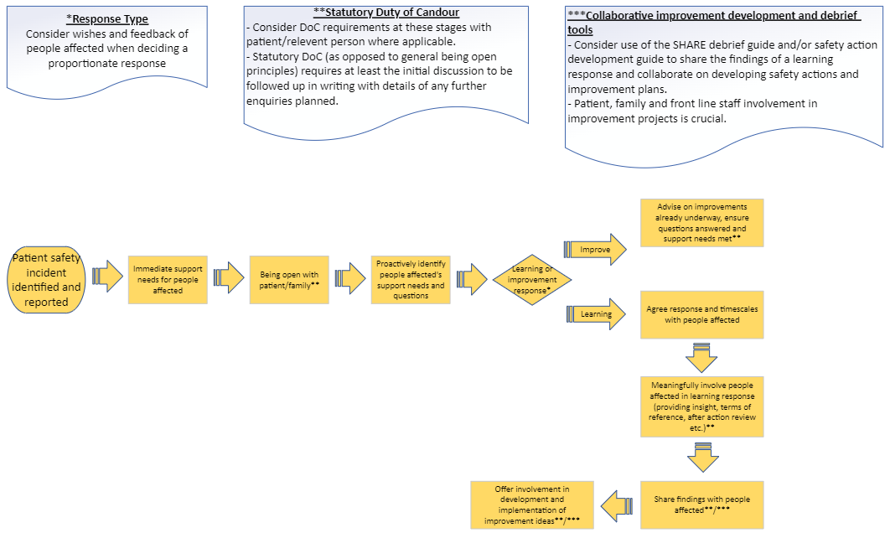

# Our patient safety incident response plan

## National requirements for patient safety incident investigation

|  |  |  |
| --- | --- | --- |
| **National criteria** | **Required response** | **Anticipated improvement route** |
| Incidents meeting the Never Events criteria | Patient Safety Incident Investigation | * Develop safety actions or improvement to address new insight and/or emerging safety issues identified. * Incorporate insight into ongoing improvement plans. |
| Death thought more likely than not due to problems in care (learning from deaths criteria) |
| Maternity and neonatal incidents meeting Maternity and Newborn Safety Investigations (MNSI) programme criteria | Referred to MNSI for independent patient safety incident investigation |

## National requirements for other external/linked process

|  |  |  |
| --- | --- | --- |
| **Event type** | **Required response** | **Anticipated improvement route** |
| Child deaths | Refer for Child Death Overview Panel review. A locally-led PSII (or other response) may be required alongside the panel review – based on discussion with the panel. | * Incorporate insight into ongoing improvement plans. * Develop safety actions or improvement to address new insight and/or emerging safety issues identified. |
| Deaths of persons with learning disabilities | Refer for Learning Disability Mortality Review (LeDeR). A locally-led PSII (or other response) may be required alongside LeDeR review – based on discussion with the panel. |
| Safeguarding incidents (as per PSIRF) | Refer to local authority safeguarding lead.  The organisation will contribute towards domestic independent inquiries, joint targeted area inspections, child safeguarding practice reviews, domestic homicide reviews and any other safeguarding reviews (and inquiries) as required to do so by the local safeguarding partnership (for children) and local safeguarding adults boards. |
| Incidents in NHS screening programmes | Refer to ‘Managing Safety Incidents in NHS Screening Programmes’ [guidance](https://www.gov.uk/government/publications/managing-safety-incidents-in-nhs-screening-programmes/managing-safety-incidents-in-nhs-screening-programmes). Refer to local screening quality assurance service for consideration of locally led learning response. |
| Accidental or unintended exposure to ionising radiation | Refer to Ionising Radiation (Medical Exposure) Regulations (IR(ME)R) and reporting requirements.  Consider appropriate and proportionate local response. |
| Haemovigilance (blood transfusion) | Refer to Serious Hazards of Transfusion (SHOT) guidance and reporting requirements.  Consider appropriate and proportionate local response. |

## Historic investigation and learning response demand

The implementation of PSIRF has led to an 84% reduction in investigation/response demand across the organisation up to the end of 2024. This equates to an approximate 37300 hours per year.

## Expected learning response and patient safety incident investigation demand

The analysis in the Trust’s PSIRF evaluation in 2024 concluded that the expected demand for 2025 would likely be an average of 78 learning responses per month. Predominantly these are likely to be after action reviews, with the one third split between observational studies, walkthrough analysis and MDT reviews.

It is anticipated that the organisation will continue to undertake the same number of patient safety incident investigations based on the national requirements above as has been undertaken in the in the first 18 months of PSIRF. This would include;

|  |  |
| --- | --- |
| **National requirements** | **Demand** |
| Patient safety incident investigation per month, under either the learning from deaths or never events criteria per month | 1 per month |
| Cross-system patient safety incident investigations | 1 per quarter |
| Patient safety incident investigations under the MNSI criteria (and therefore led externally). | 1 every other month |

Based on the above and the current limited capacity for undertaking patient safety incident investigations, the Trust plans to undertake the following additional patient safety incident investigations;

|  |  |
| --- | --- |
| **Local priorities** | **No. of investigations planned** |
| Delays in recognising deterioration linked to gaps in patient monitoring due to patient refusal or agitation for patients with a known vulnerability such as a learning disability, mental health condition or acute delirium. | 1 |
| Access to medicines, particularly for vulnerable patients, at interfaces of care or non-inpatient settings. | 1 |
| Other rationale, such as large scope for potential new insight | 1-2 per year |

## Organisational patient safety incident response capacity

|  |  |
| --- | --- |
| **Role** | **Number\*** |
| Trained learning response leads | 252 |
| Trained patient safety incident investigation leads (central patient safety team) | 5 |
| Trained engagement leads | 186 |
| Trained oversight leads | 87 |

*as at May 2025

## Patient safety incident response selection

### Patient safety incident response selection flowchart

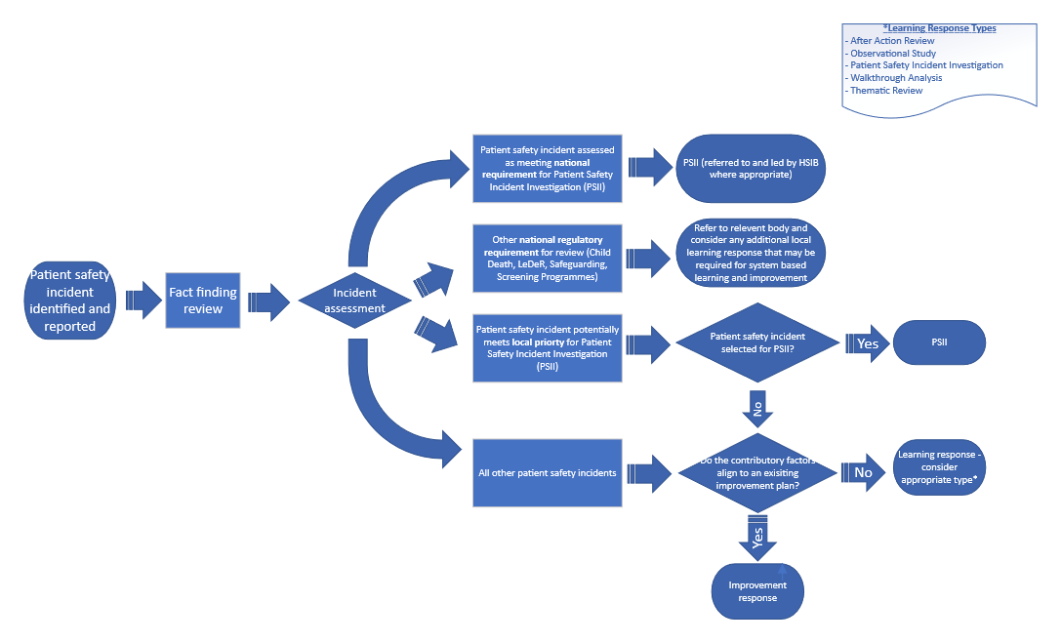

### Response types

### Learning response

Where contributory factors are not well understood or improvement work is limited in scope of effectiveness, a learning response may be required to fully understand the context and underlying factors that influenced the outcome. This includes patient safety incidents relating to new, emerging or escalating patient safety issues that have not been the subject to previous learning responses.

A ‘learning response’ covers any system-based methodology and may be used to respond to one or a cluster of patient safety incidents.

### Improvement response

Where a safety issue or incident type is well understood (e.g. because previous learning responses or investigations into incidents of this type have been completed) **AND** improvement interventions or plans (of any type) targeted at system based contributory factors are being implemented and monitored for effectiveness) resources are better directed at improvement rather than carrying out further learning responses.

In these situations, an ‘improvement response’ is indicated. This still requires compassionate engagement steps to be fulfilled, but no individual learning response to understand the context and underlying system factors.

### Learning response methodologies

The Trust will primarily use the learning response methodologies listed below. Alternative methodologies may be utilised providing they are system based and developed and conducted in liaison with the Patient Safety Team. Templates to support use of these learning responses are available on InPhase. Outputs of responses must be recorded within the patient safety incident record.

|  |  |  |  |
| --- | --- | --- | --- |
| **Methodology** | **Patient safety incident response use** | **Types of Patient Safety Incidents this response might be appropriate for** | **Other uses** |
| Patient safety incident investigation (PSII) | For in-depth system-based investigations in line with either;   * national priorities listed above * local priorities where the incident is selected by the organisation for investigation.   PSIIs may incorporate other additional methodologies to support analysis. | Where a patient safety incident investigation is indicated. | Nil |
| After action review | A structured, facilitated, supportive discussion of an event to help understand how the design of the system contributed to an event outcome differing from what was expected and to identify areas for improvement. | Incidents within a defined team and relatively short time span (e.g. inpatient medication safety incident, safer procedures) | Learning from good care (appreciative enquiry) |
| Observational study | To understand work as done rather than work as imagined/prescribed | Any individual or group of incidents. | Learning from everyday work (safety II) |
| Walkthrough analysis | Process mapping work as done of a process or task. | Task or process related incidents or patient safety themes (e.g. referral management or medication administration) | Proactive risk identification |
| Multidisciplinary team (MDT) review | Open MDT discussion regarding one or more patient safety incidents (or a theme). Involving multiple staff who have different perspectives on how the system functions in practice (work as done) to identify areas for improvement. | Any patient safety theme, including clusters of incidents, particularly where it is not possible to involve directly staff affected in an after-action review. | Proactive risk identification  Learning from good care (appreciative enquiry)  Learning from everyday work (safety II) |

### Response selection principles

An appropriate, proportionate response should be selected based on factors including;

* whether the contributary factors are already understood both in general for the type of incident and for the circumstances of the specific event.
* the expected potential for new insight (e.g. a new, emerging, or escalating safety challenge).
* alignment with the local patient safety priorities listed in section 3.7 above.
* whether improvement work is already underway to address the identified contributory factors.
* whether there is evidence that improvement work is having the intended effect/benefit.
* the views of those affected, including patients and their families.
* which type of learning response (or combination of learning response methodologies) will provide the richest insight into the underlying system factors (see table in 5.7.3 above).
* capacity available to undertake a learning response versus the capacity to implement improvement work.
* any concern that health inequalities may be a contributory factor.

### Collaborative working

* + - 1. Internal collaboration across multiple care groups/departments
* A systems approach to patient safety will lead to many patient safety incidents being identified which involve more than one Care Group (or other department).
  + Many patient pathways involve the collaboration of multiple specialities to deliver high quality care.
  + Any patient safety incident involving a non-patient owning service (e.g. a diagnostic, theatre or corporate team) will, by definition, also involve the Care Group responsible for the patient’s care.
* A collaborative approach between Care Groups or departments involved must take place to;
  + ensure a plan to deliver compassionate engagement of all people affected is developed.
  + agree a proportionate response based on whether contributory factors are understood is agreed.
* Where a learning response is agreed, a single learning response lead must be appointed and a single collaborative learning response undertaken.
  + - 1. External collaboration across multiple providers
* PSIRF encourages learning responses covering the wider system or patient pathway in which care is delivered. Where these span organisational boundaries a collaborative approach, with a single learning response commissioned involving multiple providers is indicated, rather than silo, disjointed work.
* System vulnerabilities often appear at the interface of providers, and may not be visible to any individual organisation in a pathway. Disjointed working also acts as a barrier to compassionate engagement, particularly with patients and families affected.
* Where any patient safety incident is identified involving another provider, consideration should be given to collaborative learning. If this is not relevant or possible then the patient safety must be shared with the other provider(s) with the offer of collaborative working and details of compassionate engagement undertaken to date (including verbal duty of candour).
* Where a learning response is commissioned (from within the Trust, or by another organisation) which spans organisational boundaries, these are called cross-system learning responses.
* Cross-system learning responses will generally be managed by local Trusts to facilitate the involvement of people affected and those responsible for delivery of the services. A discussion as to which provider is the lead provider responsible for ensuring the learning response is completed should be agreed.
* Where a cross-system learning response involves a large number of providers, or is of significant complexity, it can be escalated to the Trust PSIRF Panel for consideration of requesting the South East London Integrated Care Board (SEL ICB) lead the learning responses rather than any one provider involved.

### Proportionate response decision making process

The following process will used to agree a proportionate response, allocate response resource and respond to significant emerging issues where this is the potential for significant new insight;

* First line - response selection made by Care Group
  + Review of all patient safety incidents recorded through a regular Care Group/departmental PSIRF Panel (with regularity and attendance determined by the Care Group/department based on their safety profile, capacity and expected volume of incidents). Review based on fact finding carried out prior to the meeting to inform decision making based on engagement needs and suspected systematic contributory factors.
  + Agree a plan for each event, including both a compassionate engagement plan for people affected and a proportionate response (including the commissioning of learning responses, excluding patient safety incident investigations).
  + Appointment of learning responses leads, engagement leads and oversight leads as required.
  + Escalation of events where;
    - Support with developing a compassionate engagement plan for people affected is required.
    - Support for determining the most proportionate response is required, including where local review identifies a possible PSII.
    - Support with collaboration between different Care Groups, Divisions, Sites or Providers is required.
    - There is significant potential for new insight which should be escalated and/or shared more widely.
* Second line – Trust Executive oversight
  + Weekly Trust PSIRF Panel incorporating both Trust Executive input and Trustwide representation to;
    - Provide senior input in decision making and to response to escalation of emerging or escalating patient safety issues
    - Facilitate sharing of awareness and learning across Divisions.
    - Support collaboration on responses across Care Groups and Divisions.
  + Review of all events escalated by Care Groups as per the above.
  + Review of all events where;
    - A PSII based on a national requirement may be indicated.
    - A PSII based on our local PSII priorities may be considered.
    - It has been identified there is significant potential for new insight, an emerging or escalating patient safety risk or other events warranting senior oversight.
  + Decision making to include;
    - Agreement of compassionate engagement plans for people affected.
    - Agreement of a proportionate response for each case, including the commissioning of learning responses including patient safety incident investigations.
    - Agreement to request an Integrated Care Board led cross-system learning response.

**Response flow chart by role**

|  |  |  |  |  |  |  |  |  |  |
| --- | --- | --- | --- | --- | --- | --- | --- | --- | --- |
| **Response** | **Oversight Lead** | **Engagement Lead** | | **Learning Response Lead** | | | **Oversight Lead** | | |
| Learning Response | Agree an engagement plan, including appointing engagement lead if indicated. | Ensure people affected are supported | Facilitate meaningful involvement | Incorporate perspectives and ideas of people affected | | | Ensure learning response reflects involvement of people affected | Ensure compassionate engagement has been carried out (inc. statutory duty of candour steps where applicable) | Ensure statutory duty of candour steps (where applicable have been carried out) |
| Determine proportionate response, including appointing learning response lead. |  | | Undertake system-based learning response | Analyse and identify system factors | Develop Recomme-ndations | Assess learning response to ensure meets requirements | Develop and resource improvement interventions to address recommend-dations. | Monitor delivery and efficacy of improvement interventions |
| Improvement Response | Agree an engagement plan, including appointing engagement lead if indicated. | Ensure people affected are supported | Ensure people affected understand rationale for response |  | | | Ensure compassionate engagement has been carried out (inc. statutory duty of candour steps where applicable) | | Monitor delivery and efficacy of ongoing improvement interventions |

# Improvement

## Improvement oversight structure

## Other patient safety improvement groups and workstreams, including Transformation Programmes

Although the themes above have been assessed for prioritisation, the Trust recognises that there are other important patient safety themes which affect our patients and staff. These themes align with established groups, departments and other programmes as below. Periodic monitoring and oversight of patient safety improvement activities will continue to carried out by the Patient Safety Committee.

|  |  |
| --- | --- |
| Group/committee(s) with responsibility for improvement delivery | Patient safety theme(s) |
| Mental Health Improvement Group | Mental health safety |
| Maternal and Neonatal Improvement Group | Maternal and Neonatal Safety |
| Transformation Programmes;   * Integrated Patient Flow Improvement Programme * Surgical Flow and Oversight Programme * Emergency Department Improvement Programme * Same Day Emergency Care Transformation * Modernising Medicine | Operational safety – patient flow, capacity and pathways  Discharge safety |
| Transformation Programmes;   * Outpatient Transformation Programme | Operational safety – referral mgmt., tracking and lost to follow up |
| Falls improvement group | Falls |
| Pressure ulcer improvement group | Pressure ulcers |
| Hospital Transfusion Committee | Blood transfusion safety |
| Infection Prevention and Control Committee | Infection prevention and control |
| VTE Improvement Group | VTE prevention |
| Periodic monitoring via Patient Safety Committee | Screening service safety |
| End of Life Committee | Palliative and end of life care safety |
| Medical Exposure and Radiation Protection Committee | Radiation safety |
| Nutrition Steering Group | Nutrition and hydration safety |
| Medical Device Committee | Medical device safety |
| Digital Board Safety Subgroup | Digital safety |
| Estates development | Improving the safety of the physical estate |

## Use of patient safety incident learning responses to inform improvement

Learning responses completed by trained Learning Response Leads will include an analysis of the work system, highlighting vulnerabilities created by interactions of different factors and make recommendations for how they could be improved.

Oversight Leads will review the findings and recommendations within learning responses to do one or more of the below;

* develop safety actions where a system-based solution to an issue is evident.
* use the insight to inform ongoing local patient safety improvement plans.
* commission quality improvement projects to develop and test improvement ideas.
* collaborate with internal and external partners to ensure improvement is not siloed.
* escalate ideas for improvement through a relevant senior or Trustwide group.
* record and escalate system vulnerabilities which cannot be practically and effectively resolved or mitigated using the risk register.

Improvement plans and safety actions should be developed collaboratively with people affected by patient safety incidents and frontline staff, patients and their families, in line with quality improvement methodologies.

Tools such as the SHARE debrief guide and safety action development guide are recommended for supporting the sharing of insight gained through a learning response and the collaborative development of improvement ideas.

Improvement plans to improve patient safety should be developed utilising insight from responding to patient safety incidents, triangulated with a wide range of sources of insight as per the Trust’s Patient Safety Incident Response Policy.

Tools and coaching to design and deliver improvement plans can be accessed via the Quality Improvement Team. This includes scale and spread methodologies such as the IHI Collaborative methodology where the required improvement solution is already known.

## Other improvement activities

Most organisational activity is aimed, at least in part, at improving patient safety. The improvement activities above relate predominantly to specific safety improvement work. The organisation recognises that many other improvement activities or interventions can address systematic contributory factors to patient safety incidents (and therefore meet the requirements of selecting an improvement response as a proportionate response).

This includes, but is not limited to;

* Operational transformation programmes.
* ICT improvement activities or projects – e.g. optimisation of EPIC.
* Estates improvements, e.g. building work, repairs or upgrades to the physical environment in which care is delivered.
* Workforce and organisational development work – e.g. recruitment to vacant posts, improving the wellbeing or fatigue and improving interpersonal working or team cultures.
* Equipment – e.g. roll out of new or additional medical devices.
* Mitigation plans for items on the risk register.
* Action plans associated with other quality governance activities such as mortality reviews, complaints and audits.
* Implementation of new NICE guidance (or similar).
* Work associated with external inspections or regulatory requirements.

## Recording and monitoring improvement

|  |  |
| --- | --- |
| Source/route | Method |
| Improvement responses | Record within the incident record the specific piece of improvement work currently ongoing, and how and where it is being monitored. |
| Patient safety incident investigations | Record system findings and recommendations within the investigation report, summarise within the incident record and upload the investigation report.  Record the agreed action plan developed in response to the investigation within the investigation report.  Safety actions resulting from patient safety incident investigations will be overseen and monitored by the patient safety committee. They will be recorded and tracked on the overarching patient safety incident investigations action tracker. |
| Other learning responses | Record system findings and recommendations within the learning response report, summarise within the incident record and upload the learning response report.  Safety actions will be agreed through Care Group oversight processes in response to the findings and recommendations within the learning response. This may also include recorded how recommendations align with, or are being used to inform, ongoing improvement activities or plans.  Safety actions will be recorded on the Care Group’s quality governance action tracker from where they will be overseen and monitored. |
| Other improvement activities outside of patient safety incident responses | Quality improvement work will be recorded on the Quality Improvement and Innovation (QII) module on InPhase, where progress will be overseen by the QII team and relevant Care Group leads. |

The Trust aims to move to a centralised, electronic recording of safety actions, via InPhase, through the life of this plan. This will be implemented to improve oversight of the delivery and effectiveness of safety actions, along with wider improvement work.

# Patient safety incident response oversight

## Oversight principles and systems

Oversight principles and systems as set out in the Patient Safety Incident Policy will be followed.

Oversight processes will focus on the spirit of PSIRF through;

* ensuring the processes for considering proportionate responses and engagement plans are effective.
* ensuring improvement work is underway for known safety challenges and risks.
* ensuring people affected by patient safety incidents are compassionately engaged and supported.
* ensuring learning responses have been completed, have meaningfully involved people affected and are system based in both their findings and recommendations.
* directing improvement activities based on the findings and recommendations of learning responses.
* recording risks on the risk register for system for vulnerabilities that cannot be addressed currently.
* focusing attention and resources on the delivery of improvement activities, and the evaluation of these activities to ensure they are effective.
* supporting collaboration on both insight and improvement activities
* being curious to understand the safety of the system through multiple sources and approaches.

## Response completion

The response should be recorded as ‘response complete’ within the incident management system when the following steps have been completed in the table below;

|  |  |  |  |  |
| --- | --- | --- | --- | --- |
| Response Type | Methodology | Incident response | Compassionate engagement | Oversight |
| Improvement response | n/a | * Confirmed contributory factors already understood and effective improvement plan in place. | * Being open [and DoC where applicable] completed with people affected. * Support needs and questions proactively sought and resolved. | * Plan for continuous monitoring of effectiveness of improvement plan in place. * Any obvious local safety actions implemented. * Processes to monitor effective selection of response, compassionate engagement, and effectiveness of improvement in place. |
| Learning response | Patient Safety Incident Investigation | * Learning response commissioned completed and system insight recorded. | * Being open [and DoC where applicable] completed with people affected. * Support needs and questions proactively sought and resolved. * People affected actively engaged in the response. * System findings shared. * Collaboration with people affected on improvement ideas. | * PSII report reviewed and signed off by Executive Lead for Patient Safety to ensure response was system based; compassionate engagement principles followed etc. * Insight and recommendations used to generate safety actions and/or inform wider improvement plans. * Monitoring of delivery and effectiveness of improvement plan by Patient Safety Committee. |
| After Action Review | * Response reviewed by relevant oversight lead/governance meeting to ensure response was system based; compassionate engagement principles followed etc. * Insight used to generate local safety actions and/or inform wider improvement plans. * Monitoring of delivery and effectiveness of improvement plan agreed. |
| Observational Study |
| Walkthrough Analysis |
| MDT Review |

Table 1 - Patient safety incident response standards

1. NHS England (2022). *SEIPS quick reference guide.* Available from <https://www.england.nhs.uk/wp-content/uploads/2022/08/B1465-SEIPS-quick-reference-and-work-system-explorer-v1-FINAL.pdf>*.* 
2. The Shelford Group (2025). *Members*. Available from <https://shelfordgroup.org/members/>
3. Patient Safety Learning (2025). *Patient Safety Incident Response Plans: An analysis and reflection by*

   *Patient Safety Learning*. Available from <https://d2z1laakrytay6.cloudfront.net/Report_PSIRPS_AnanalysisandreflectionbyPatient-Safety-Learning_Issued.pdf>
4. Illingworth J, Fernandez Crespo R, Hasegawa K, Leis M, Howitt P, Darzi A. (2024). *The National State of Patient Safety 2024: Prioritising improvement efforts in a system under stress.* Imperial College London. Available from <https://www.imperial.ac.uk/Stories/National-State-Patient-Safety-2024/>
5. NHS England (2022). *Patient Safety Incident Response Framework supporting guidance; Engaging and involving patients, families and staff following a patient safety incident.* Available from <https://www.england.nhs.uk/wp-content/uploads/2022/08/B1465-2.-Engaging-and-involving...-v1-FINAL.pdf>