NHS SOUTHWARK Musculoskeletal Referral Form

(Incorporating MCATS, Orthopaedics and Non-inflammatory
Rheumatology referrals)
*Excludes routine physiotherapy, fracture clinic, urgent A&E referrals and suspected cancer
2-week wait.
If patient requires physiotherapy, please refer directly and not via this MCATS form
Please complete form and refer using NHS e-Referrals service (formerly Choose and Book)
Guy’s and St Thomas’ NHS FT
Musculoskeletal Service
3rd Floor, Lambeth Wing
St Thomas’ Hospital
Westminster Bridge Rd, London SE1 7EH
Email: gst-tr.MCATs@nhs.net
: 020 7188 7612
King’s College Hospital NHS FT
MCATS
Therapy Suite, 1st Floor Golden Jubilee Wing
King’s College Hospital, Denmark Hill,
London SE5 9RS
Email: kch.therapyreferrals@nhs.net
: 020 3299 8213

Patient Details
Title: Title Name: Forenames Surname DoB: DOB Sex: Sex

Address: Patient Address List

Home Telephone No: Home Telephone Mobile: Mobile Telephone Work:
NHS Number: NHS Number
Interpreter required YES NO If yes, which language?
Is patient off work due to this problem pain? NO YES If yes, how long for?
Provisional diagnosis (including any specific indication for direct referral to ortho/rheum):  Would this patient consider surgery for this problem if appropriate? YES NO | Anticipated Initial review by:  Any  Or would prefer  MSK CATS  Orthopaedics  Rheumatology  OR  Specific Clinician if appropriate:
Please mark symptom distribution on chart  Unlock the form:  - Office 2003 click on View, Toolbars, Forms and click on padlock  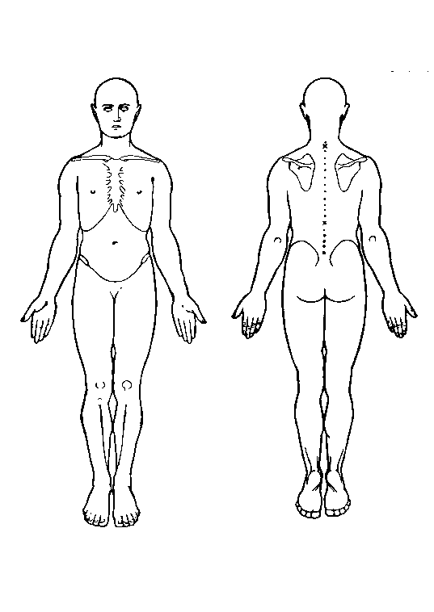  - Office 2007 click on Developer, Protect Document, Restrict formatting, Stop Protection, then drag and drop the crosses | What clinical question do you want answered by this referral?  Clinical presentation/history  PTO

Current Episode of Spinal Pain
Duration of Symptoms <6/52 6/52–3/12 3/12-6/12 >1year
Acute 1st Episode
Acute Exac / Chronic condition
Onset: Spontaneous Following minor back strain Following major injury

Relevant Investigations:
X-ray  Scans  Blood Test | Lower Limb x-rays in weight- bearing. PLEASE ATTACH REPORT | When | Where

Relevant PMH
Current/ Previous treatment/ Drug allergy

Allergy Table
Medication Table

Medication
Physiotherapy
Other

RED FLAGS
Weight loss(more than 10% of body weight in 3-6/12)  Severe, unremitting night pain  Fever  Gait disturbance  History of serious pathology  systemic illness e.g. malignancy  Structural deformity  Bilateral changes in sensation in hands +/-  Feet lower limb hyper-reflexia +/- clonus | Inflammatory presentation  Night pain Multiple joint pain  Resting pain AM stiffness  (How long?)  History of? Iritis Inflam bowel  Urethritis Psoriasis  Family Hx of inflamm disease  Abnormal abdominal examination  Lumps and Bumps (ganglions, masses)
Neurological Signs present Cx/Tx spine?  Sensory loss Dysphasia  Muscle weakness Dizziness  Altered Reflex Drop attacks  Nausea Dysarthria  Severe and constant headache | Neurological Signs present Lx spine?  Sensory loss  Muscle weakness  Altered Reflex  Positive SLR

DO NOT USE THIS FORM FOR ROUTINE PHYSIOTHERAPY. PLEASE REFER PATIENTS TO MSK PHYSIOTHERAPY VIA E-REFERRALS SERVICE USING CORRECT FORM.

GP Name:

Practice Address:

Signature: Date: System Date

Incomplete forms will be returned to the referrer

