LAMBETH AND SOUTHWARK
EARLY ARTHRITIS REFERRAL FORM
DATE OF REFERRAL |  | URGENT / NON URGENT
Hospital Clinic Referring to | King’s College Hospital  kch-tr.KCHReferrals@nhs.net |  | Guy’s Hospital  FAX: 0207 407 7532

Section 1 PATIENT INFORMATION |  | D.O.B. |  | GENDER M/F
SURNAME |  | NHS NUMBER
FIRST NAME |  | HOSPITAL NUMBER
ADDRESS |  | FIRST LANGUAGE
 |  | INTERPRETER REQUIRED? Y/N
 |  | TRANSPORT REQUIRED? Y/N
TELEPHONE NUMBERS
DAYTIME | HOME |  | MOBILE

Section 2 PRACTICE INFORMATION | REFERRING GP
PRACTICE ADDRESS | TELEPHONE NUMBER
PRACTICE ADDRESS | FAX NUMBER

Section 3 CLINICAL INFORMATION | Please tick relevant referral criteria and indicate involved joints on the diagram
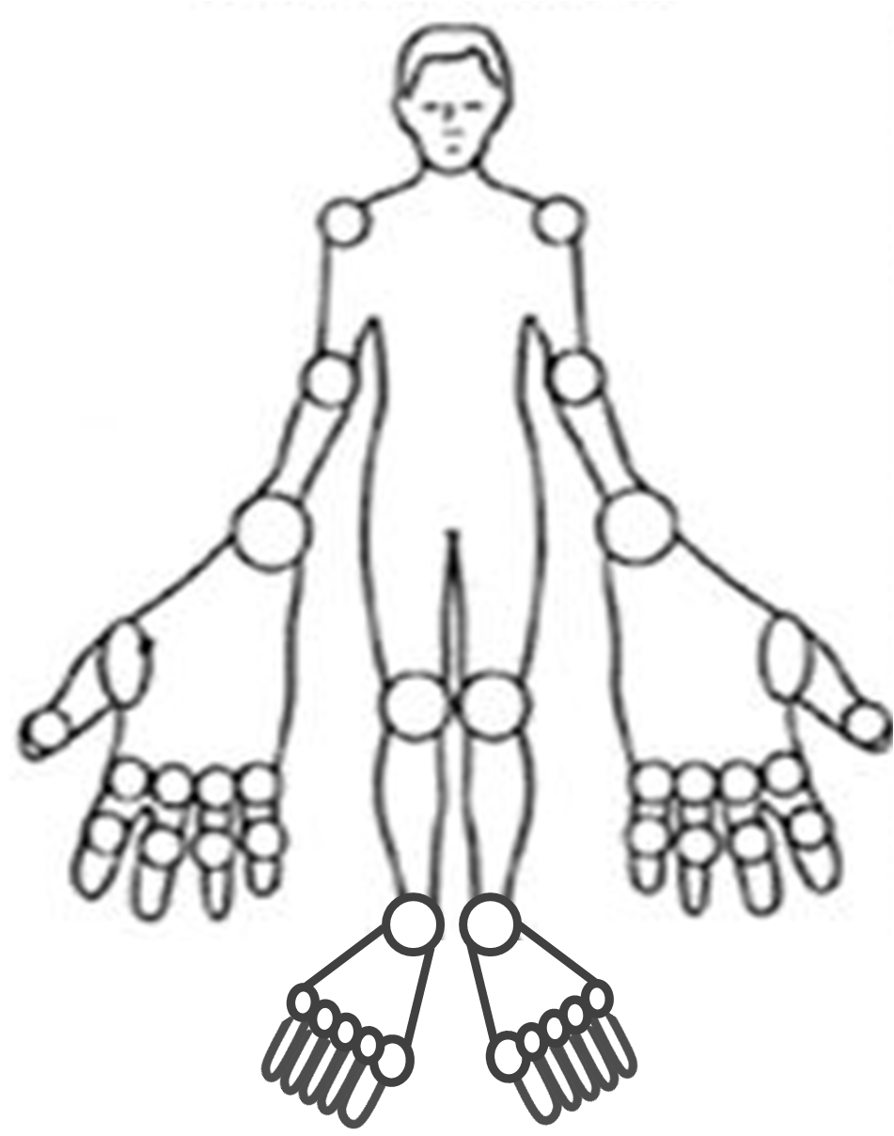  Other affected joints:…………………………………………….. | Please refer any patient with suspected inflammatory arthritis for 6 weeks or more urgently if any of the following apply  - Swelling in two or more joints  - Positive MCPJ or MTPJ squeeze test  - Small joint of hands and feet or wrists affected  Please mark the affected joints on the diagram opposite  Date of symptom onset…………………  Other features/information – continue on separate sheet if required.  Please attach patient summary sheet.  ………………………………………………  ………………………………………………

Section 4 INVESTIGATIONS TO BE ARRANGED AT REFERRED INSTITUTION AT TIME OF REFERRAL. Please tick box to indicate requested. Do not wait for result before referring.
Full Blood Count (FBC)  | Renal Function Tests (U&E)  | Liver Function Tests (LFT)  | Erythrocyte Sedimentation Rate (ESR)   | C-Reactive Protein(CRP)  | Rheumatoid Factor (RF)  | Anti-nuclear Antibody (ANA) 

Section 5 Information to support Early Arthritis referrals
NICE Guidance on ‘The management of rheumatoid arthritis in adults’ (February, 2009), advises that:
Early persistent joint inflammation (synovitis) must be treated as soon as possible to prevent irreversible damage to joints.
Synovitis is characterised by joint pain and joint swelling, although significant swelling may NOT be obvious clinically
Patients should be referred urgently if there has been a delay of 6 weeks of longer between symptom onset and seeking medical advice and any of the following apply:
● There is more than 1 joint affected
● The small joints of the hands or feet are affected
● There is a positive MCPJ or MTPJ squeeze
Other features suggestive of inflammatory arthritis include:
● Early morning joint stiffness >30 minutes
● Joint stiffness following periods of immobility
● Constitutional upset, such as loss of appetite, weight loss, fatigue
● The presence of extra-articular features of inflammatory arthritis such as psoriasis, iritis or uveitis, inflammatory bowel disease
Do not avoid referring urgently any person with suspected persistent inflammatory arthritis whose blood tests show a normal acute phase response or negative rheumatoid factor.
X-rays will usually be carried out following the Rheumatology out-patient clinic consultation, however, please append the reports of any recent X-rays carried out.
For further information please refer to the Early Arthritis Clinic page under Rheumatology Services at www.gstt.nhs.uk

ANY QUERIES
Kings College Hospital  e-mail: kch-tr.RheumatologyAppointments@nhs.net | Guy’s Hospital  e-mail: Rheumatology dept@gstt.nhs (responded to during working hours)

